**Job Application Tracking System - (Developer)**

Create a CRM Application which helps the applicant to track the No. of jobs he applied and helps him to find the job posted by the various recruiters, find the best attributes to be involved to run the process in a smooth way and easily to track.

**Salesforce**

What Is Salesforce?  
  
Salesforce is your customer success platform, designed to help you sell, service, market, analyze, and connect with your customers.  
  
Salesforce has everything you need to run your business from anywhere. Using standard products and features, you can manage relationships with prospects and customers, collaborate and engage with employees and partners, and store your data securely in the cloud.  
  
So what does that really mean? Well, before Salesforce, your contacts, emails, follow-up tasks, and prospective deals might have been organized something like this:

<https://youtu.be/r9EX3lGde5k>

**Creating A Salesforce Developer Org**

A Developer org has all the features and licenses you need to get started with Salesforce.  
  
1.Search Developer.salesforce.com/signup  
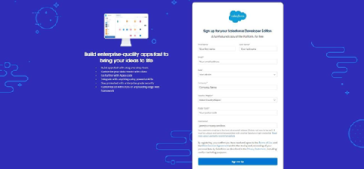   
2.Enter the following details like First name, last name, Email, Role, Company, Country/Region, Postal code, and Username must be unique.  
  
3.Click sign me up, after a few min you will reserve a mail salesforce org and by using the verify account link you can create your new password.  
  
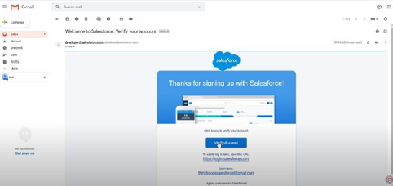  
  
4. Click save.  
  
5.Search login.salesforce.com  
  
6.By using username and password you can into the Salesforce org.  
  
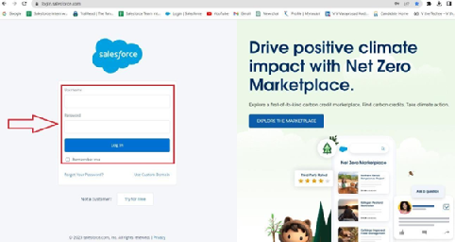  
  
The home page will appear as below.

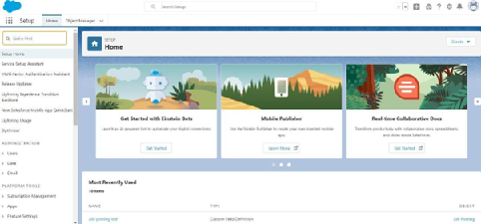

**Creating A Salesforce Developer Org**

A Developer org has all the features and licenses you need to get started with Salesforce.  
  
1.Search Developer.salesforce.com/signup  
   
2.Enter the following details like First name, last name, Email, Role, Company, Country/Region, Postal code, and Username must be unique.  
  
3.Click sign me up, after a few min you will reserve a mail salesforce org and by using the verify account link you can create your new password.  
  
  
  
4. Click save.  
  
5.Search login.salesforce.com  
  
6.By using username and password you can into the Salesforce org.  
  
  
  
The home page will appear as below.



**Creating A Salesforce Developer Org**

A Developer org has all the features and licenses you need to get started with Salesforce.  
  
1.Search Developer.salesforce.com/signup  
   
2.Enter the following details like First name, last name, Email, Role, Company, Country/Region, Postal code, and Username must be unique.  
  
3.Click sign me up, after a few min you will reserve a mail salesforce org and by using the verify account link you can create your new password.  
  
  
  
4. Click save.  
  
5.Search login.salesforce.com  
  
6.By using username and password you can into the Salesforce org.  
  
  
  
The home page will appear as below.



**Creating A Salesforce Developer Org**

A Developer org has all the features and licenses you need to get started with Salesforce.  
  
1.Search Developer.salesforce.com/signup  
   
2.Enter the following details like First name, last name, Email, Role, Company, Country/Region, Postal code, and Username must be unique.  
  
3.Click sign me up, after a few min you will reserve a mail salesforce org and by using the verify account link you can create your new password.  
  
  
  
4. Click save.  
  
5.Search login.salesforce.com  
  
6.By using username and password you can into the Salesforce org.  
  
  
  
The home page will appear as below.



**Creating A Salesforce Developer Org**

A Developer org has all the features and licenses you need to get started with Salesforce.  
  
1.Search Developer.salesforce.com/signup  
   
2.Enter the following details like First name, last name, Email, Role, Company, Country/Region, Postal code, and Username must be unique.  
  
3.Click sign me up, after a few min you will reserve a mail salesforce org and by using the verify account link you can create your new password.  
  
  
  
4. Click save.  
  
5.Search login.salesforce.com  
  
6.By using username and password you can into the Salesforce org.  
  
  
  
The home page will appear as below.



**Creating A Salesforce Developer Org**

A Developer org has all the features and licenses you need to get started with Salesforce.  
  
1.Search Developer.salesforce.com/signup  
   
2.Enter the following details like First name, last name, Email, Role, Company, Country/Region, Postal code, and Username must be unique.  
  
3.Click sign me up, after a few min you will reserve a mail salesforce org and by using the verify account link you can create your new password.  
  
  
  
4. Click save.  
  
5.Search login.salesforce.com  
  
6.By using username and password you can into the Salesforce org.  
  
  
  
The home page will appear as below.



**Creating A Salesforce Developer Org**

A Developer org has all the features and licenses you need to get started with Salesforce.  
  
1.Search Developer.salesforce.com/signup  
   
2.Enter the following details like First name, last name, Email, Role, Company, Country/Region, Postal code, and Username must be unique.  
  
3.Click sign me up, after a few min you will reserve a mail salesforce org and by using the verify account link you can create your new password.  
  
  
  
4. Click save.  
  
5.Search login.salesforce.com  
  
6.By using username and password you can into the Salesforce org.  
  
  
  
The home page will appear as below.



**Creating A Salesforce Developer Org**

A Developer org has all the features and licenses you need to get started with Salesforce.  
  
1.Search Developer.salesforce.com/signup  
   
2.Enter the following details like First name, last name, Email, Role, Company, Country/Region, Postal code, and Username must be unique.  
  
3.Click sign me up, after a few min you will reserve a mail salesforce org and by using the verify account link you can create your new password.  
  
  
  
4. Click save.  
  
5.Search login.salesforce.com  
  
6.By using username and password you can into the Salesforce org.  
  
  
  
The home page will appear as below.



**Object**

**What is an object?**  
  
Salesforce objects are database tables that permit you to store data that is specific to an organization. It consists of fields (columns) and records (rows).  
Salesforce objects are of two types:  
  
Standard Objects: Standard objects are the kind of objects that are provided by salesforce.com such as users, contracts, reports, dashboards, etc.  
Custom Objects: Custom objects are those objects that are created by users. They supply information that is unique and essential to their organization. They are the heart of any application and provide a structure for sharing data.  
  
1.In This Application We Use 4 Custom Objects:  
2.Recruiter  
3.Jobs  
4.Candidate  
5.Job-Application

**Create A Custom Object For Recruiter**

Create a custom object for Recruiter:  
  
To create a custom object, follow these steps:  
1. From setup click on object manager.  
2. Click create, select custom object.  
  
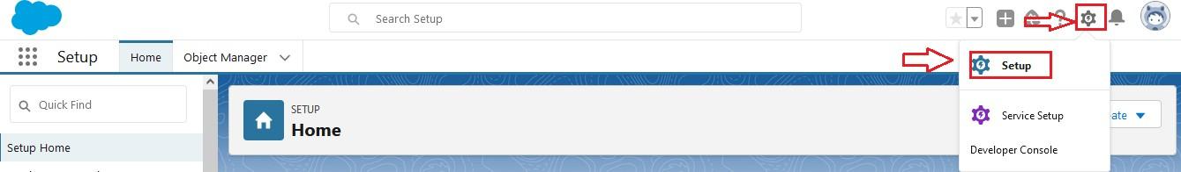  
  
  
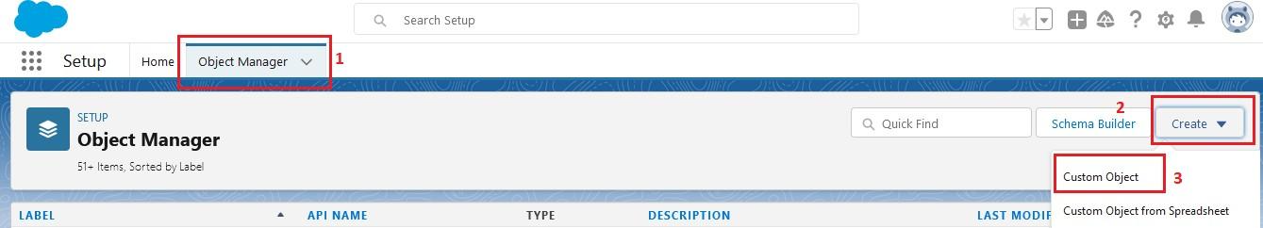  
  
  
  
  
3. Fill in the label as " Recruiter ".  
4. Fill in the plural label as " Recruiters".  
5. Record name: " Recruiter Name"  
6. Select the data type as "Text".  
7. In the Optional Features section, select Allow Reports and Track Field History.  
8. In the Deployment Status section, ensure Deployed is selected.  
9. In the Search Status section, select Allow Search.  
10. In the Object Creation Options section, select Add Notes and Attachments related list to default page layout.

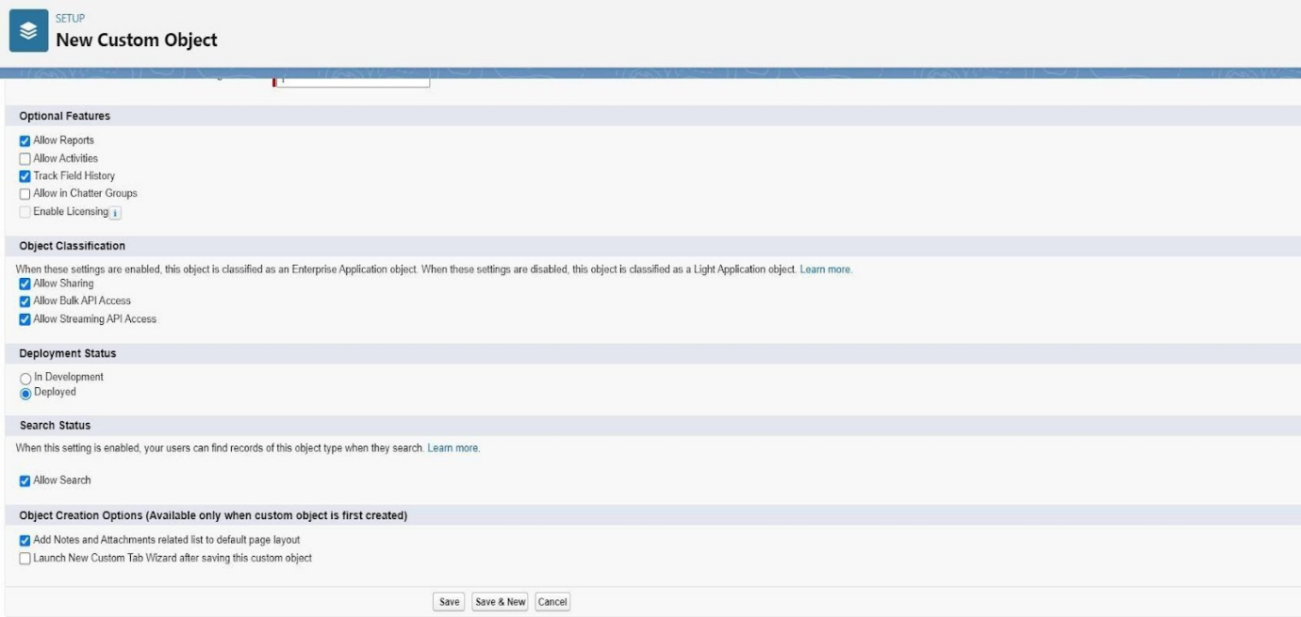

11. Leave everything else as is, and click Save.

**Creation Of Jobs Object**

Click on the gear icon and then select Setup.  
  
1. Click on the object manager tab just beside the home tab.  
  
2. After the above steps, have a look on the extreme right you will find a Create Dropdown click on that and select Custom Object.  
  
3. On the Custom Object Definition page, create the object as follows:

* Label: Job
* Plural Label: Jobs
* Record Name: Job Name
* Select the data type as "Text".
* Check the Allow Reports checkbox
* Check the Allow Search checkbox
* In the Object Creation Options section, select Add Notes and Attachments related list to default page layout
* Click Save.

**Creation Of Candidate Object**

1. Click on the gear icon and then select Setup.
2. Click on the object manager tab just beside the home tab.
3. After the above steps, have a look on the extreme right you will find a Create Dropdown click on that and select Custom Object.

* On the Custom Object Definition page, create the object as follows:
* Label: Candidate
* Plural Label: Candidates
* Record Name: Candidates Name
* Select the data type as "Text".
* Check the Allow Reports checkbox.
* Check the Allow Search checkbox.
* In the Object Creation Options section, select Add Notes and Attachments related list to default page layout.
* Click Save.

**Creation Of Job Application Object**

* Click on the gear icon and then select Setup.
* Click on the object manager tab just beside the home tab.
* After the above steps, have a look on the extreme right you will find a Create Dropdown click on that and select Custom Object.
  + On the Custom Object Definition page, create the object as follows:
  + Label: Job Application
  + Plural Label: Job Applications
  + Record Name: Job Application Number
  + Select the data type as "Auto Number".
  + Under display format enter "JP-{0000}"
  + Enter starting number as 1
  + Check the Allow Reports checkbox.
  + Check the Allow Search checkbox.
  + In the Object Creation Options section, select Add Notes and Attachments related list to default page layout.
  + Click Save.

### Tab

**Tab**  
Tabs in Salesforce help users view the information at a glance. It displays the data of objects and other web content in the application.  
  
There are mainly 4 types of tabs:  
 **Standard Object Tabs**:  
Standard object tabs display data related to standard objects.  
  
**Custom Object Tabs:**  
Custom object tabs display data related to custom objects. These tabs look and function just like standard tabs.  
**Web Tabs:**  
Web Tabs display any external Web-based application or Web page in a Salesforce tab.  
  
**Visualforce Tabs:**  
Visualforce Tabs display data from a Visualforce Page.  
  
NOTE: we won’t be dealing with web tabs and visualforce tabs later.

**Creation Of Recruiter Tab**

Now create a custom tab.

Click on Home tab, enter Tabs in Quick Find and select Tabs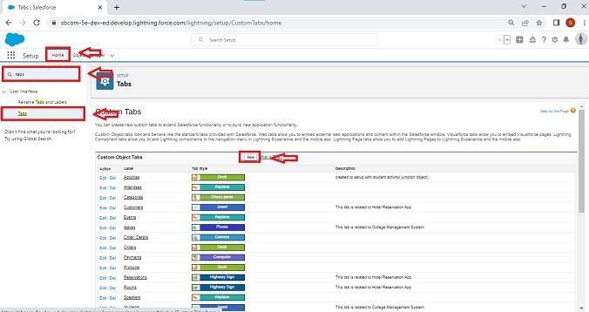  
  
  
  
2.Under custom object tabs, click New.  
  
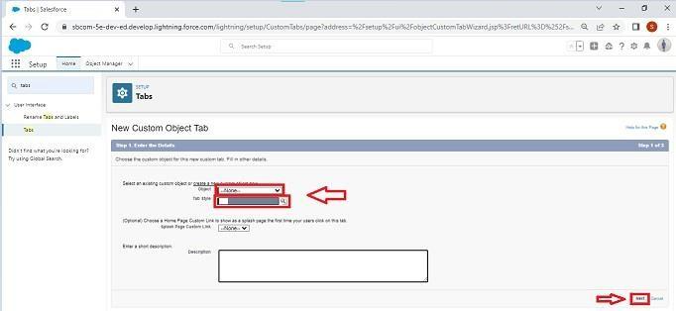  
  
3.For Object, select Recruiter.  
4.For Tab Style, select any icon.  
5.Leave all defaults as is. Click Next, Next, and Save.

**Creation Of Job Tab**

Now create a custom tab.

1. Click on Home tab, enter Tabs in Quick Find and select Tabs.  
2. Under custom object tabs, click New.  
3. For Object, select Job.  
4. For Tab Style, select any icon.  
5. Leave all defaults as is. Click Next, Next, and Save.

**Creation Of Candidate Tab**

Now create a custom tab.

1. Click on Home tab, enter Tabs in Quick Find and select Tabs.
2. Under custom object tabs, click New.
3. For Object, select Candidate.
4. For Tab Style, select any icon.
5. Leave all defaults as is. Click Next, Next, and Save.

**Creation Of Job Application Tab**

Now create a custom tab.

1. Click on Home tab, enter Tabs in Quick Find and select Tabs.
2. Under custom object tabs, click New.
3. For Object, select Job Application.
4. For Tab Style, select any icon.
5. Leave all defaults as is. Click Next, Next, and Save.

**Lightning App**

What is an App?  
  
Apps in Salesforce are a group of tabs that help the application function by working together asa unit. It has a name, a logo, and a particular set of tabs. The simplest app usually has just two tabs.  
  
There are 2 types of Salesforce applications:

* Standard apps: these apps come with every occurrence of Salesforce as default. Community, Call Center, Content, Sales, Marketing, Salesforce Chatter, Site.com, and App Launcher are included in these apps. The description, logo, and label of a standard app cannot be altered.
* Custom apps: these apps are created according to the needs of a company. They can be made by putting custom and standard tabs together. Logos for custom apps can be changed.

**Create The Job Application Tracking App**

* From Setup, enter App Manager in the Quick Find and select App Manager.

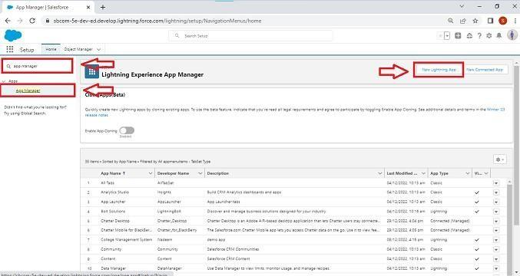

* Click New Lightning App. Job Application Tracking as the App Name, then click Next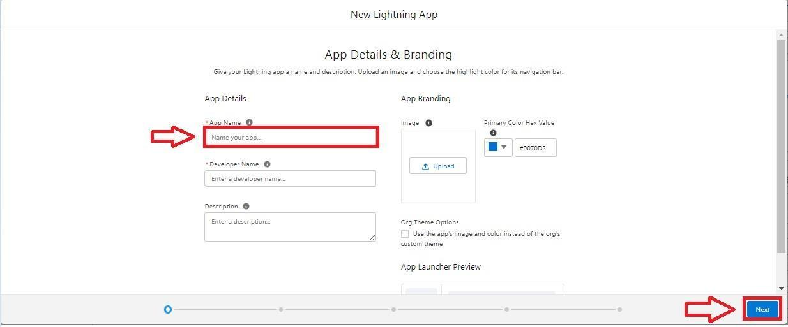
* Under App Options, leave the default selections and click Next.
* Under Utility Items, leave as is and click Next.
* From Available Items, select Recruiters, Jobs,Candidates,Job Application Reports,and Dashboards and move them to Selected Items. Click Next.

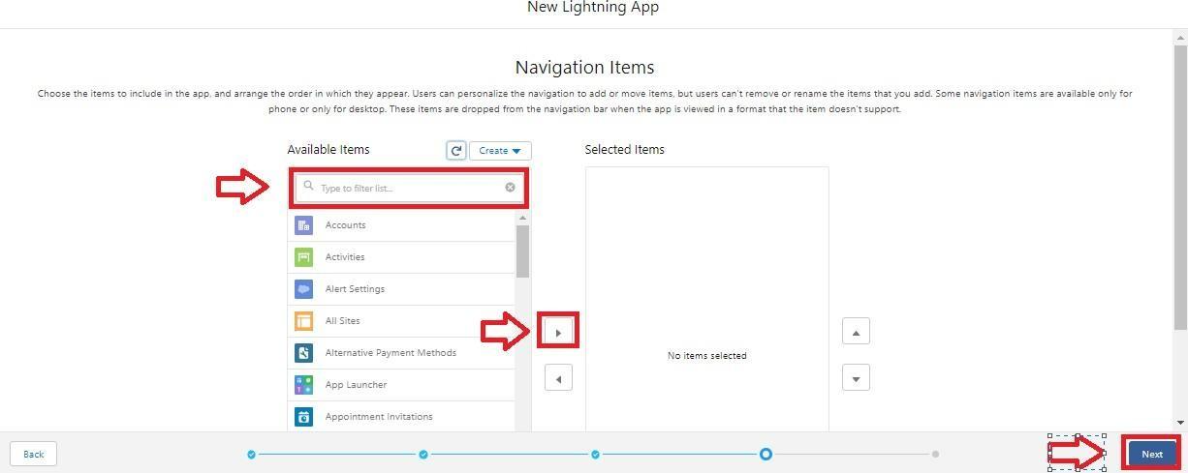

* From Available Profiles, select System Administrator and move it to Selected Profiles.Click Save & Finish.

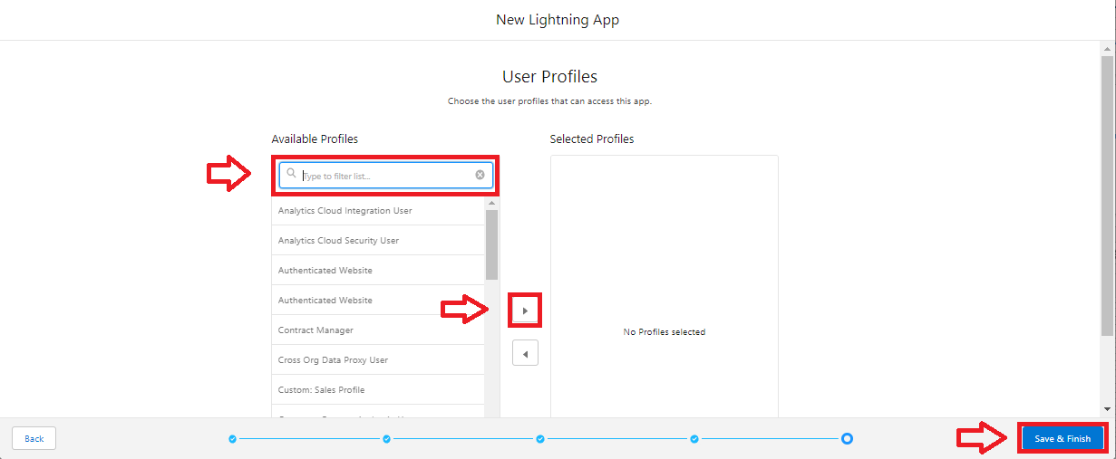

* To verify your changes, click the App Launcher, type Job Application and select the Job Application app.

Note:

1. App Launcher-Displays available apps.
2. App Name-Displays the current selected app.
3. Navigation menu-Displays the tabs available inside the app.

**Fields And Relationship**

What are fields?

Fields in Salesforce represent what the columns represent in relational databases. It can store data values which are required for a particular object in a record.

There are 2 types of fields in salesforce:

* Standard fields: There are four standard fields in every custom object that are Created By, Last Modified By, Owner, and the field created at the time of the creation of an object. These fields cannot be deleted or edited and they are always required. For standard objects, the fields which are present by default in them and cannot be deleted from standard objects are standard fields.
* Custom fields: The Custom fields which are added by the administrator/developer to meet the business requirements of any organization. They may or may not be required.

**Creation Of Fields For The Recruiter Objects**

1. click the gear icon and select Setup. This launches Setup in a new tab.
2. Click the Object Manager tab next to Home.
3. Select Recruiter.
4. Select Fields & Relationships from the left navigation, and click New

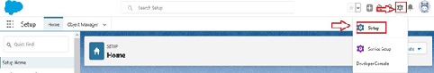  
  
  
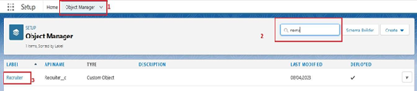  
From the sidebar, click Fields & Relationships. Notice that there are already some fields there. Those are the standard fields.  
  
  
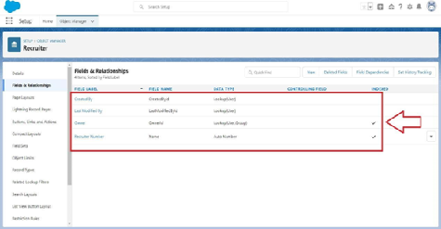  
  
  
Click New to create a custom field. Tip: Before creating a new field, do a quick search to make sure a similar one doesn’t already exist.  
  
  
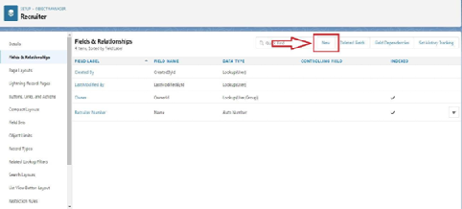  
5.Choose the data type as Auto number, click next  
  
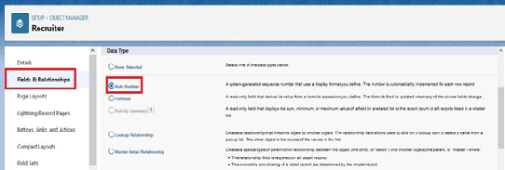  
  
6.Enter field label(Recruiter Number), Display formate RN-{0000} Starting number(1) and click next  
  
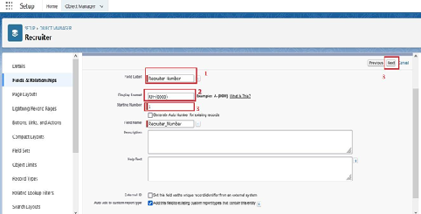  
7.Next,Next and Click save.  
  
Now let's create the other fields follow above Activity1 steps 1 to 4 and we must choose the data types of the fields carefully  
 Select the Text as the Data Type, then click Next. For Field Label, Job Title. Enter Length (20) Click Next, Next, then Save & New.

1. Select the Email as the Data Type, then click Next. For Field Label, Email.
2. Click Next, Next, then Save & New.
3. Select the phone as the Data Type, then click Next. For Field Label, Phone.
4. Click Next, Next, then Save & New.

### Creation Of Fields For The Job Objects

**Follow the above steps from 1 to 4 of activity 1**  
1.Select the Auto number as the Data Type, then click Next.

For Field Label, enter Job Application Id., Display format (J-{000}) starting number (001) Click Next, Next, then Save & New  
  
2.Select the Text area as the Data Type, then click Next. For Field Label, Description.

Click Next, Next, then Save & New.

3.Select the **Text** as the Data Type, then click Next. For Field Label, enter Location, and length (20) Click Next, Next, then Save & New

**Creation Of Master-Detail Relationship For Job Object**

1.From Setup, go to Object Manager  
2.On the sidebar, click Fields & Relationships.  
3.Click New.  
  
  
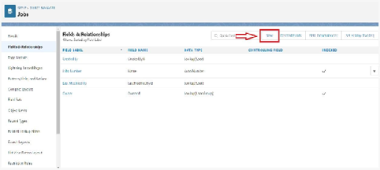  
  
4.Choose Master-detail Relationship and click Next

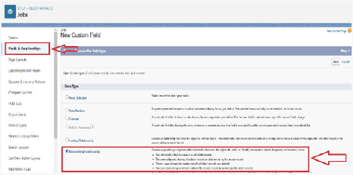

5.Choose the related object(Recruiter) and select that object.

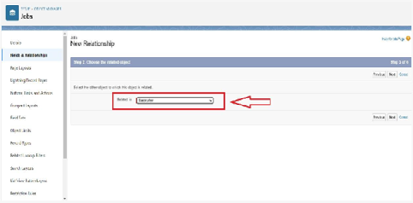  
  
6.Enter the label name(Recruiter Name)  
  
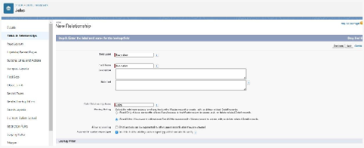  
7.Click Next, Next, and Save

**Creation Of Fields For The Candidate Object**

Follow the above steps from 1 to 4 of activity 1  
1.Select the Text area as the Data Type, then click Next. For Field Label, Address,  
Click Next, Next, then Save & New.  
2.Select the Email as the Data Type, then click Next. For Field Label, enter Email.  
Click Next, Next, then Save & New.  
3.Select the Phone as the Data Type, then click Next. For Field Label, enter Phone.  
Click Next, Next, then Save & New  
4.Select Picklist as the Data Type and click Next. For Field Label enter Education.  
Select Enter values, with each value separated by a new line and enter these values: Graduation ,  
Post-Graduation. Click Next, Next, then Save & New.  
5.Select the Text area as the Data Type, then click Next. For Field Label, enter Skill Set.   
Click Next, Next, then Save & New

**Create Picklist Fields On Candidate Object**

* Click on the gear icon and then select Setup.
* Click on the object manager tab just beside the home tab.
* After the above steps, Select candidate Object
* Now Select Fields and relationships from setup menu of the candidate object.
* Click new and select Picklist fields ????next and enter label name(State) and select enter values option

                               (Rajasthan, UP, MP, Punjab), next, next and Save.

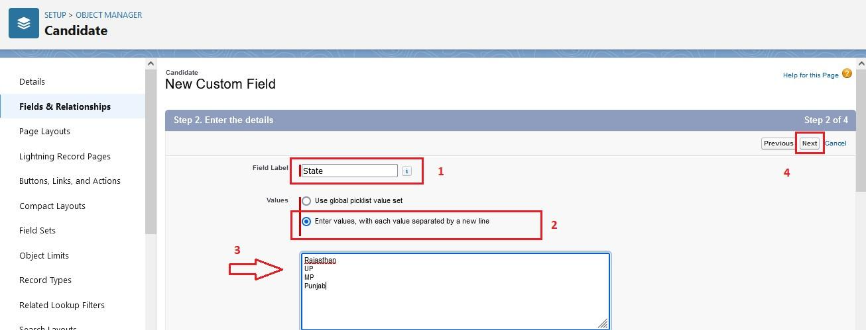  
  
Follow same above steps for create city and Education Picklist fields with their values.  
1.Select Picklist as the Data Type and click Next. For Field Label name City  
                                    And Select Enter values, with each value separated by a new line and enter these values  
                                       (Jaipur, Jalandhar, Lucknow, Bhopal), next, next and Save.  
2.Select Picklist as the Data Type and click Next. For Field Label enter Education.  
    Select Enter values, with each value separated by a new line and enter these values: Graduation ,  
    Post-Graduation. Click Next, Next, then Save & New

**Create Field Dependency (On Candidate Object)**

Create a dependency between these two picklists, so that when a state is selected, only respective Values are available.  
The below steps will assist you in creating Field Dependencies.

* Click on the gear icon and then select Setup.
* Click on the object manager tab just beside the home tab.
* After the above steps, Select Candidate Object
* Now Select Fields and relationships from setup menu of the Candidate object.
* Click Field Dependencies.
* Click New.
* Select State as the Controlling Field and select City as the Dependent Field.
* Click Continue.
* Select the appropriate Value in each column by double-clicking them.
* For Ex. Rajasthan - Jaipur
* Click Include Values. And it is also same for UP, MP& Punjab with its city.
* Click Preview, then test the dependency by selecting different State and viewing the associate Values available for Particular state.
* Click Close to close the preview window.
* Click Save.

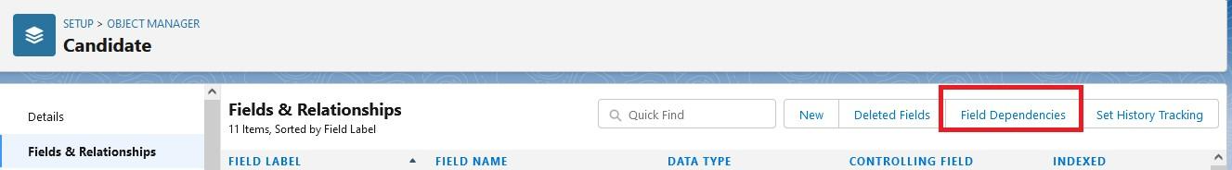  
  
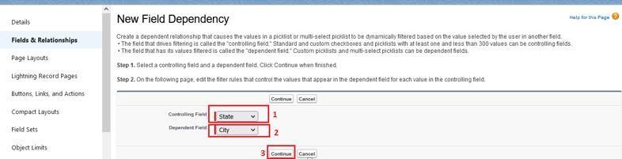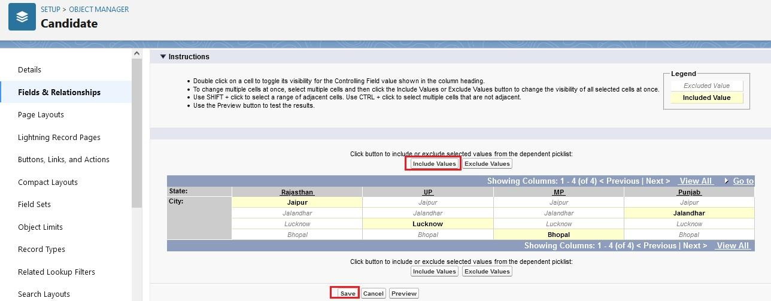

**Creation Lookup Relationship For The Job Application Objects**

**Let’s create two lookup relationship on job application object First lookup relationship**  
**From Setup, go to Object Manager**

* On the sidebar, click Fields & Relationships.
* Select Lookup relationship & click next
* Choose the related object as Candidate & click next
* Give the field label(Candidate name) & click next, next, next and Save

**Second lookup relationship**

* From Setup, go to Object Manager
* On the sidebar, click Fields & Relationships.
* Select Lookup relationship & click next
* Choose the related object as Job & click next
* Give the field label(Job Name) & click next, next, next and Save
* **Profile**
* What is a profile?  
    
  A profile is a group/collection of settings and permissions that define what a user can do in salesforce. A profile controls “Object permissions, Field permissions, User permissions, Tab settings, App settings, Apex class access, Visualforce page access, Page layouts, Record Types, Login hours & Login IP ranges.  
    
  A profile can be assigned to many users, but user can be assigned single profile at a time.

**[](https://apsche.smartinternz.com/Student/guided_project_info/6481)**[Toggle navigation](https://apsche.smartinternz.com/Student/guided_project_info/6481)

* [**0**](https://apsche.smartinternz.com/Student/guided_project_info/6481)
* [**Dashboard**](https://apsche.smartinternz.com/Student/dashboard)
* [**Internship**](https://apsche.smartinternz.com/Student/externships)
* [**Support**](https://apsche.smartinternz.com/Student/support)
* [**Training Calendar**](https://apsche.smartinternz.com/Student/training_calendar)
* [**Guided Project**](https://apsche.smartinternz.com/Student/guided_project_info/6481#menu1)
* [**Project Workspace**](https://apsche.smartinternz.com/Student/guided_project_workspace/6481)



* Job Application Tracking System - (Developer)
  + Salesforce
    - Creating A Salesforce Developer Org
  + Object
    - Create A Custom Object For Recruiter
    - Creation Of Jobs Object
    - Creation Of Candidate Object
    - Creation Of Job Application Object
  + Tab
    - Creation Of Recruiter Tab
    - Creation Of Job Tab
    - Creation Of Candidate Tab
    - Creation Of Job Application Tab
  + Lightning App
    - Create The Job Application Tracking App
  + Fields And Relationship
    - Creation Of Fields For The Recruiter Objects
    - Creation Of Fields For The Job Objects
    - Creation Of Master-Detail Relationship For Job Object
    - Creation Of Fields For The Candidate Object
    - Create Picklist Fields On Candidate Object
    - Create Field Dependency (On Candidate Object)
    - Creation Lookup Relationship For The Job Application Objects
  + Profile
    - Create A Custom Profile
    - Create A Custom Profile-2
  + Role
  + User
  + Sharing Rules
  + User Adoption
  + Reports
  + Dashboard
  + View Report And Dashboard
  + Flows

**Create A Custom Profile**

1.From setup , enter profiles in Quick Find box  
2.Select profiles (Standard user).  
3.Click clone.  
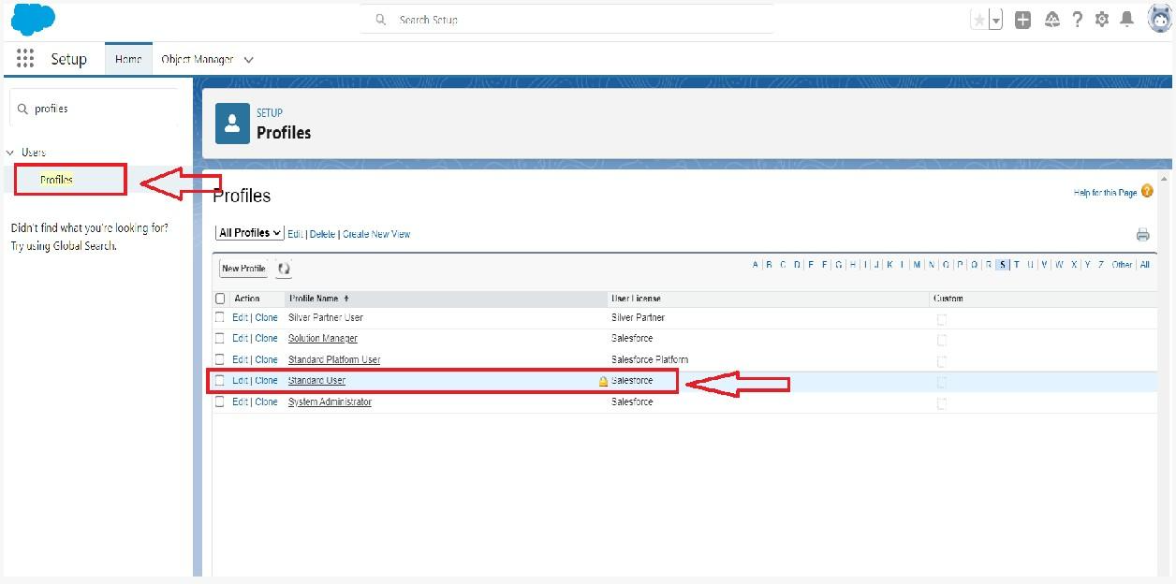

4.For Profile, enter Recruiter.  
  
  
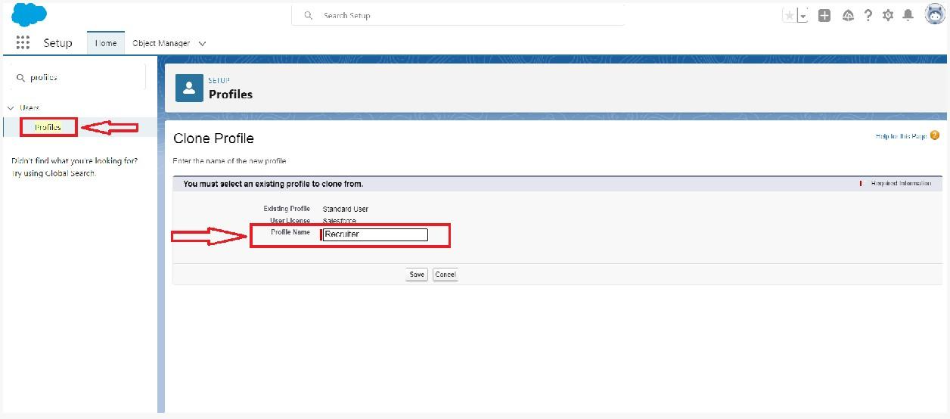  
5.Click save.

**[](https://apsche.smartinternz.com/Student/guided_project_info/6481)**[Toggle navigation](https://apsche.smartinternz.com/Student/guided_project_info/6481)

* [**0**](https://apsche.smartinternz.com/Student/guided_project_info/6481)
* [**Dashboard**](https://apsche.smartinternz.com/Student/dashboard)
* [**Internship**](https://apsche.smartinternz.com/Student/externships)
* [**Support**](https://apsche.smartinternz.com/Student/support)
* [**Training Calendar**](https://apsche.smartinternz.com/Student/training_calendar)
* [**Guided Project**](https://apsche.smartinternz.com/Student/guided_project_info/6481#menu1)
* [**Project Workspace**](https://apsche.smartinternz.com/Student/guided_project_workspace/6481)



* Job Application Tracking System - (Developer)
  + Salesforce
    - Creating A Salesforce Developer Org
  + Object
    - Create A Custom Object For Recruiter
    - Creation Of Jobs Object
    - Creation Of Candidate Object
    - Creation Of Job Application Object
  + Tab
    - Creation Of Recruiter Tab
    - Creation Of Job Tab
    - Creation Of Candidate Tab
    - Creation Of Job Application Tab
  + Lightning App
    - Create The Job Application Tracking App
  + Fields And Relationship
    - Creation Of Fields For The Recruiter Objects
    - Creation Of Fields For The Job Objects
    - Creation Of Master-Detail Relationship For Job Object
    - Creation Of Fields For The Candidate Object
    - Create Picklist Fields On Candidate Object
    - Create Field Dependency (On Candidate Object)
    - Creation Lookup Relationship For The Job Application Objects
  + Profile
    - Create A Custom Profile
    - Create A Custom Profile-2
  + Role
  + User
  + Sharing Rules
  + User Adoption
  + Reports
  + Dashboard
  + View Report And Dashboard
  + Flows

**Create A Custom Profile-2**

Create a profile with the profile name as “Sales Manager”.   
  
1.From setup , enter profiles in Quick Find box  
2.Select profiles (Standard user).  
3.Click clone.  
  
Follow the steps from above Activity

**Role**

In Salesforce, roles are used to determine which users have access to certain data and functions within the system. They are also used to define the reporting hierarchy within an organization. Users with higher roles have greater access to data and more control over the system.

**Role**

In Salesforce, roles are used to determine which users have access to certain data and functions within the system. They are also used to define the reporting hierarchy within an organization. Users with higher roles have greater access to data and more control over the system.

**Creation Of Role**

1.From the Quick find box search for the role and click on the roles option  
2.select the set up roles option

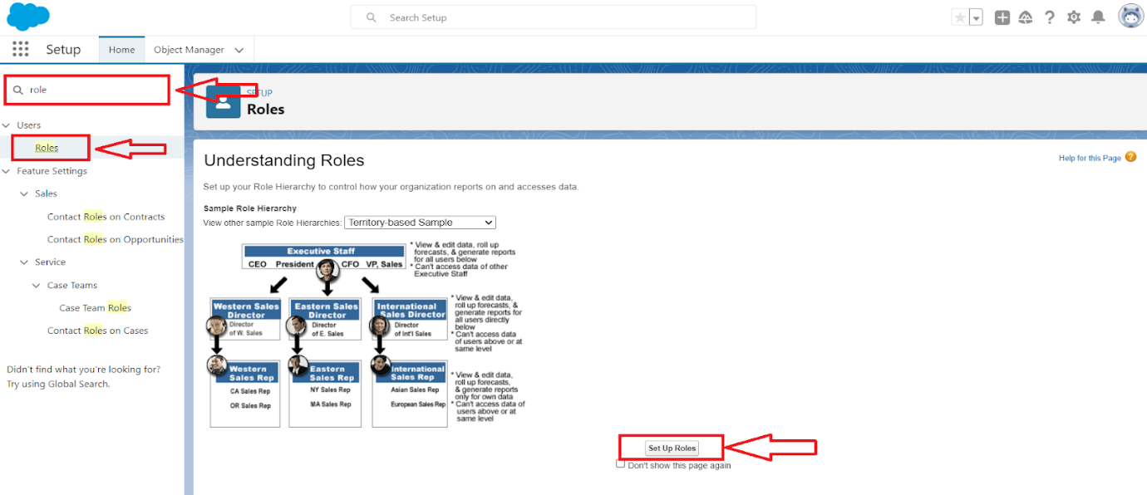

3.Below the CEO click on add role and enter the label name as a ” HR Manager ” and role name will be Automatically populated and click on save.  
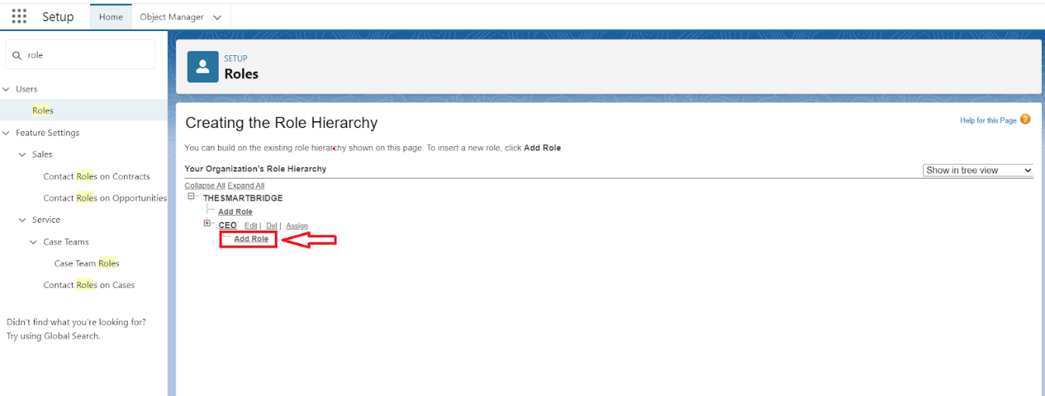  
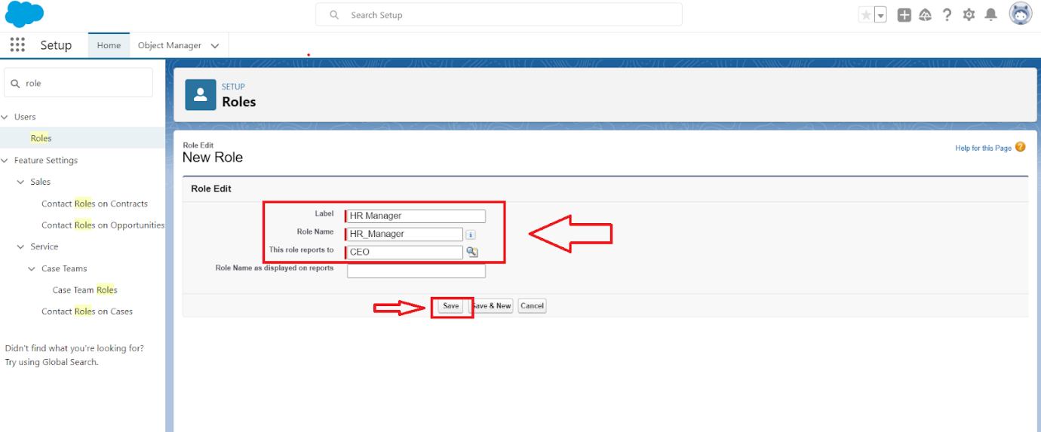

**User**

**What is a user?**  
  
A user is anyone who logs in to Salesforce. Users are employees at your company, such as sales reps, managers, and IT specialists, who need access to the company's records. Every user in Salesforce has a user account. The user account identifies the user, and the user account settings determine what features and records the user can access.  
  
NOTE- As Salesforce license can only be used by 2 Users at a time in Dev Org, so If you don’t find salesforce license then deactivate a user who has salesforce license Or change the license type from Salesforce to any other.

**[](https://apsche.smartinternz.com/Student/guided_project_info/6481)**[Toggle navigation](https://apsche.smartinternz.com/Student/guided_project_info/6481)

* [**0**](https://apsche.smartinternz.com/Student/guided_project_info/6481)
* [**Dashboard**](https://apsche.smartinternz.com/Student/dashboard)
* [**Internship**](https://apsche.smartinternz.com/Student/externships)
* [**Support**](https://apsche.smartinternz.com/Student/support)
* [**Training Calendar**](https://apsche.smartinternz.com/Student/training_calendar)
* [**Guided Project**](https://apsche.smartinternz.com/Student/guided_project_info/6481#menu1)
* [**Project Workspace**](https://apsche.smartinternz.com/Student/guided_project_workspace/6481)



* Job Application Tracking System - (Developer)
  + Salesforce
    - Creating A Salesforce Developer Org
  + Object
    - Create A Custom Object For Recruiter
    - Creation Of Jobs Object
    - Creation Of Candidate Object
    - Creation Of Job Application Object
  + Tab
    - Creation Of Recruiter Tab
    - Creation Of Job Tab
    - Creation Of Candidate Tab
    - Creation Of Job Application Tab
  + Lightning App
    - Create The Job Application Tracking App
  + Fields And Relationship
    - Creation Of Fields For The Recruiter Objects
    - Creation Of Fields For The Job Objects
    - Creation Of Master-Detail Relationship For Job Object
    - Creation Of Fields For The Candidate Object
    - Create Picklist Fields On Candidate Object
    - Create Field Dependency (On Candidate Object)
    - Creation Lookup Relationship For The Job Application Objects
  + Profile
    - Create A Custom Profile
    - Create A Custom Profile-2
  + Role
    - Creation Of Role
  + User
    - To Create A User
    - Create Another User
  + Sharing Rules
  + User Adoption
  + Reports
  + Dashboard
  + View Report And Dashboard
  + Flows

**To Create A User**

1.From Setup, enter Users in the Quick Find box, then select Users.  
2.Click New User.  
  
  
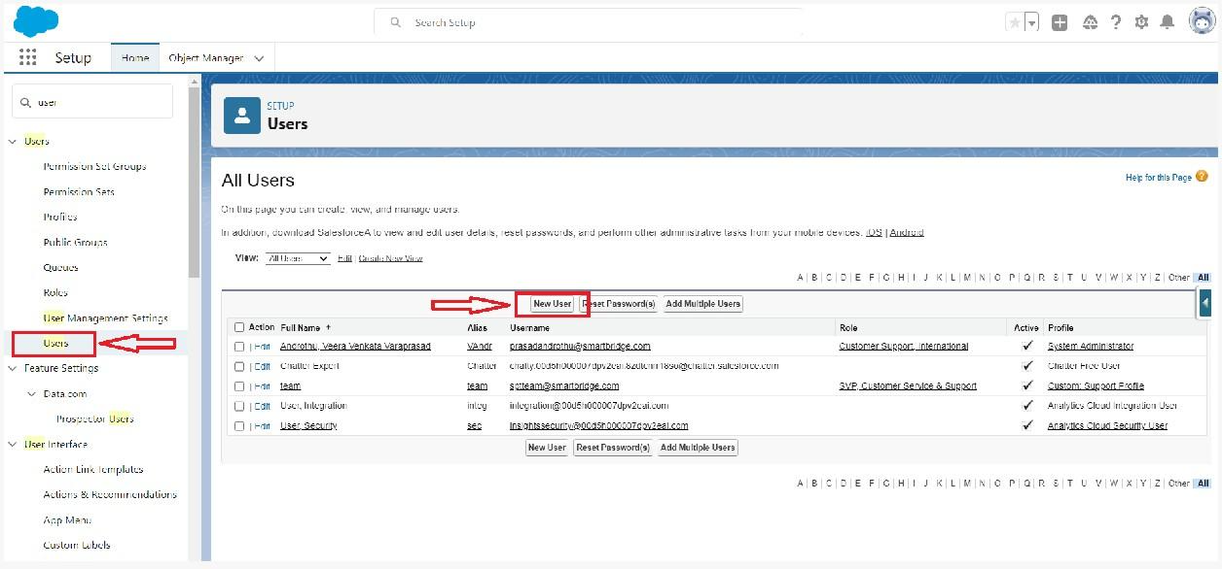  
3.Enter First name as HR and last name as Manager.  
4.Enter the user’s name and email address and a unique username in the form of an email address. By default, the username is the same as the email address.  
  
5.Then create a new role HR Manager.  
6.Select user License as Standard Platform User.  
7.Select profile(Recruiter).  
  
  
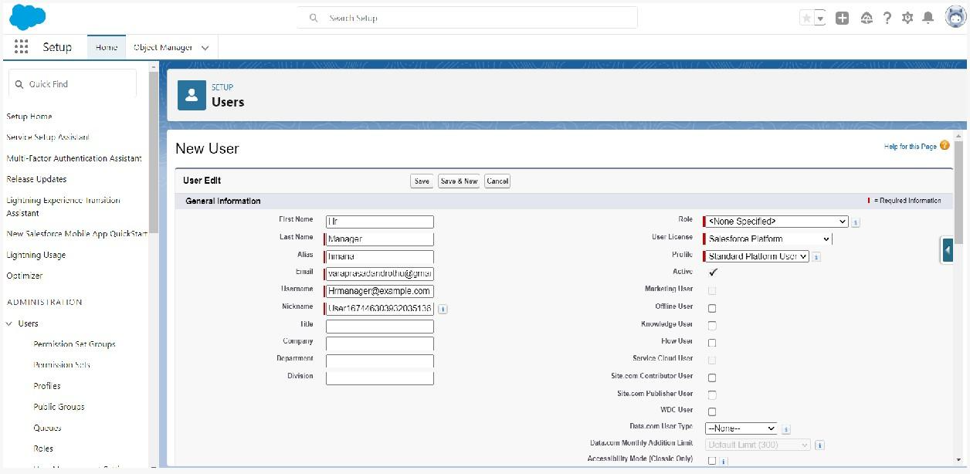  
8.Click save

**[](https://apsche.smartinternz.com/Student/guided_project_info/6481)**[Toggle navigation](https://apsche.smartinternz.com/Student/guided_project_info/6481)

* [**0**](https://apsche.smartinternz.com/Student/guided_project_info/6481)
* [**Dashboard**](https://apsche.smartinternz.com/Student/dashboard)
* [**Internship**](https://apsche.smartinternz.com/Student/externships)
* [**Support**](https://apsche.smartinternz.com/Student/support)
* [**Training Calendar**](https://apsche.smartinternz.com/Student/training_calendar)
* [**Guided Project**](https://apsche.smartinternz.com/Student/guided_project_info/6481#menu1)
* [**Project Workspace**](https://apsche.smartinternz.com/Student/guided_project_workspace/6481)



* Job Application Tracking System - (Developer)
  + Salesforce
    - Creating A Salesforce Developer Org
  + Object
    - Create A Custom Object For Recruiter
    - Creation Of Jobs Object
    - Creation Of Candidate Object
    - Creation Of Job Application Object
  + Tab
    - Creation Of Recruiter Tab
    - Creation Of Job Tab
    - Creation Of Candidate Tab
    - Creation Of Job Application Tab
  + Lightning App
    - Create The Job Application Tracking App
  + Fields And Relationship
    - Creation Of Fields For The Recruiter Objects
    - Creation Of Fields For The Job Objects
    - Creation Of Master-Detail Relationship For Job Object
    - Creation Of Fields For The Candidate Object
    - Create Picklist Fields On Candidate Object
    - Create Field Dependency (On Candidate Object)
    - Creation Lookup Relationship For The Job Application Objects
  + Profile
    - Create A Custom Profile
    - Create A Custom Profile-2
  + Role
    - Creation Of Role
  + User
    - To Create A User
    - Create Another User
  + Sharing Rules
  + User Adoption
  + Reports
  + Dashboard
  + View Report And Dashboard
  + Flows

**Create Another User**

Create a user with a username as “Ganesh Gelli”, and assign him the sales Manager profile. Follow the steps from above Activity

**[](https://apsche.smartinternz.com/Student/guided_project_info/6481)**[Toggle navigation](https://apsche.smartinternz.com/Student/guided_project_info/6481)

* [**0**](https://apsche.smartinternz.com/Student/guided_project_info/6481)
* [**Dashboard**](https://apsche.smartinternz.com/Student/dashboard)
* [**Internship**](https://apsche.smartinternz.com/Student/externships)
* [**Support**](https://apsche.smartinternz.com/Student/support)
* [**Training Calendar**](https://apsche.smartinternz.com/Student/training_calendar)
* [**Guided Project**](https://apsche.smartinternz.com/Student/guided_project_info/6481#menu1)
* [**Project Workspace**](https://apsche.smartinternz.com/Student/guided_project_workspace/6481)



* Job Application Tracking System - (Developer)
  + Salesforce
    - Creating A Salesforce Developer Org
  + Object
    - Create A Custom Object For Recruiter
    - Creation Of Jobs Object
    - Creation Of Candidate Object
    - Creation Of Job Application Object
  + Tab
    - Creation Of Recruiter Tab
    - Creation Of Job Tab
    - Creation Of Candidate Tab
    - Creation Of Job Application Tab
  + Lightning App
    - Create The Job Application Tracking App
  + Fields And Relationship
    - Creation Of Fields For The Recruiter Objects
    - Creation Of Fields For The Job Objects
    - Creation Of Master-Detail Relationship For Job Object
    - Creation Of Fields For The Candidate Object
    - Create Picklist Fields On Candidate Object
    - Create Field Dependency (On Candidate Object)
    - Creation Lookup Relationship For The Job Application Objects
  + Profile
    - Create A Custom Profile
    - Create A Custom Profile-2
  + Role
    - Creation Of Role
  + User
    - To Create A User
    - Create Another User
  + Sharing Rules
    - Create A Sharing Rule
    - Another Sharing Rule
  + User Adoption
  + Reports
  + Dashboard
  + View Report And Dashboard
  + Flows

**Sharing Rules**

What are Sharing Rules?  
  
Sharing rules help users to share records based on conditions. It is basically created for objects whose organization-wide defaults (OWD) are set to public read-only or private because sharing rules can only extend the access and not restrict it.  
  
Types of sharing rules,

* Owner-based Sharing Rules
* Criteria-based Sharing Rules

**[](https://apsche.smartinternz.com/Student/guided_project_info/6481)**[Toggle navigation](https://apsche.smartinternz.com/Student/guided_project_info/6481)

* [**0**](https://apsche.smartinternz.com/Student/guided_project_info/6481)
* [**Dashboard**](https://apsche.smartinternz.com/Student/dashboard)
* [**Internship**](https://apsche.smartinternz.com/Student/externships)
* [**Support**](https://apsche.smartinternz.com/Student/support)
* [**Training Calendar**](https://apsche.smartinternz.com/Student/training_calendar)
* [**Guided Project**](https://apsche.smartinternz.com/Student/guided_project_info/6481#menu1)
* [**Project Workspace**](https://apsche.smartinternz.com/Student/guided_project_workspace/6481)



* Job Application Tracking System - (Developer)
  + Salesforce
    - Creating A Salesforce Developer Org
  + Object
    - Create A Custom Object For Recruiter
    - Creation Of Jobs Object
    - Creation Of Candidate Object
    - Creation Of Job Application Object
  + Tab
    - Creation Of Recruiter Tab
    - Creation Of Job Tab
    - Creation Of Candidate Tab
    - Creation Of Job Application Tab
  + Lightning App
    - Create The Job Application Tracking App
  + Fields And Relationship
    - Creation Of Fields For The Recruiter Objects
    - Creation Of Fields For The Job Objects
    - Creation Of Master-Detail Relationship For Job Object
    - Creation Of Fields For The Candidate Object
    - Create Picklist Fields On Candidate Object
    - Create Field Dependency (On Candidate Object)
    - Creation Lookup Relationship For The Job Application Objects
  + Profile
    - Create A Custom Profile
    - Create A Custom Profile-2
  + Role
    - Creation Of Role
  + User
    - To Create A User
    - Create Another User
  + Sharing Rules
    - Create A Sharing Rule
    - Another Sharing Rule
  + User Adoption
  + Reports
  + Dashboard
  + View Report And Dashboard
  + Flows

**Create A Sharing Rule**

1.Go to Sharing Settings, which can be found under the Quick Find section.  
2.Scroll down and find the candidate object where a sharing rule needs to be added, and then click on New to create a new sharing rule.  
  
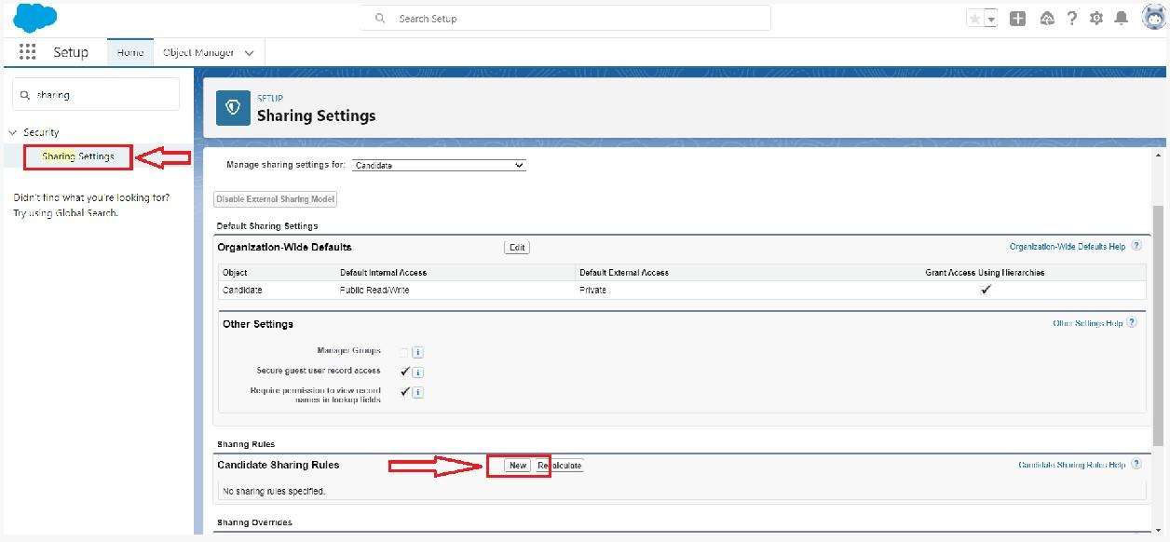  
  
3.Add the label of the sharing rule you want to make.  
4.Select your rule type based on the criteria.  
5.Select the field can join immediately check field from the candidate object.  
6.Select the State as equal and value is Rajasthan.  
7.And in selecting the users to share with the section select roles and in that select Hr Manager.  
8.And in the section of select the level of access for the users give the access Read/Write.

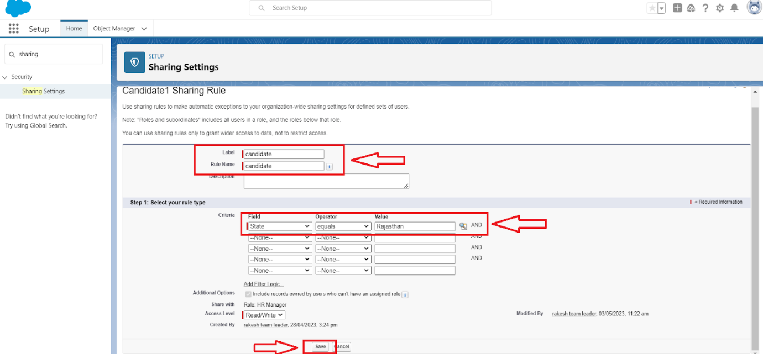

9.And save the rule.

**[](https://apsche.smartinternz.com/Student/guided_project_info/6481)**[Toggle navigation](https://apsche.smartinternz.com/Student/guided_project_info/6481)

* [**0**](https://apsche.smartinternz.com/Student/guided_project_info/6481)
* [**Dashboard**](https://apsche.smartinternz.com/Student/dashboard)
* [**Internship**](https://apsche.smartinternz.com/Student/externships)
* [**Support**](https://apsche.smartinternz.com/Student/support)
* [**Training Calendar**](https://apsche.smartinternz.com/Student/training_calendar)
* [**Guided Project**](https://apsche.smartinternz.com/Student/guided_project_info/6481#menu1)
* [**Project Workspace**](https://apsche.smartinternz.com/Student/guided_project_workspace/6481)



* Job Application Tracking System - (Developer)
  + Salesforce
    - Creating A Salesforce Developer Org
  + Object
    - Create A Custom Object For Recruiter
    - Creation Of Jobs Object
    - Creation Of Candidate Object
    - Creation Of Job Application Object
  + Tab
    - Creation Of Recruiter Tab
    - Creation Of Job Tab
    - Creation Of Candidate Tab
    - Creation Of Job Application Tab
  + Lightning App
    - Create The Job Application Tracking App
  + Fields And Relationship
    - Creation Of Fields For The Recruiter Objects
    - Creation Of Fields For The Job Objects
    - Creation Of Master-Detail Relationship For Job Object
    - Creation Of Fields For The Candidate Object
    - Create Picklist Fields On Candidate Object
    - Create Field Dependency (On Candidate Object)
    - Creation Lookup Relationship For The Job Application Objects
  + Profile
    - Create A Custom Profile
    - Create A Custom Profile-2
  + Role
    - Creation Of Role
  + User
    - To Create A User
    - Create Another User
  + Sharing Rules
    - Create A Sharing Rule
    - Another Sharing Rule
  + User Adoption
  + Reports
  + Dashboard
  + View Report And Dashboard
  + Flows

**Another Sharing Rule**

Create a Sharing Rule to Share the records of Job Application to Hr Manager with the Access of Read/Write.  
Follow the steps from above Activity.

### User Adoption

**[](https://apsche.smartinternz.com/Student/guided_project_info/6481)**[Toggle navigation](https://apsche.smartinternz.com/Student/guided_project_info/6481)

* [**0**](https://apsche.smartinternz.com/Student/guided_project_info/6481)
* [**Dashboard**](https://apsche.smartinternz.com/Student/dashboard)
* [**Internship**](https://apsche.smartinternz.com/Student/externships)
* [**Support**](https://apsche.smartinternz.com/Student/support)
* [**Training Calendar**](https://apsche.smartinternz.com/Student/training_calendar)
* [**Guided Project**](https://apsche.smartinternz.com/Student/guided_project_info/6481#menu1)
* [**Project Workspace**](https://apsche.smartinternz.com/Student/guided_project_workspace/6481)



* Job Application Tracking System - (Developer)
  + Salesforce
    - Creating A Salesforce Developer Org
  + Object
    - Create A Custom Object For Recruiter
    - Creation Of Jobs Object
    - Creation Of Candidate Object
    - Creation Of Job Application Object
  + Tab
    - Creation Of Recruiter Tab
    - Creation Of Job Tab
    - Creation Of Candidate Tab
    - Creation Of Job Application Tab
  + Lightning App
    - Create The Job Application Tracking App
  + Fields And Relationship
    - Creation Of Fields For The Recruiter Objects
    - Creation Of Fields For The Job Objects
    - Creation Of Master-Detail Relationship For Job Object
    - Creation Of Fields For The Candidate Object
    - Create Picklist Fields On Candidate Object
    - Create Field Dependency (On Candidate Object)
    - Creation Lookup Relationship For The Job Application Objects
  + Profile
    - Create A Custom Profile
    - Create A Custom Profile-2
  + Role
    - Creation Of Role
  + User
    - To Create A User
    - Create Another User
  + Sharing Rules
    - Create A Sharing Rule
    - Another Sharing Rule
  + User Adoption
    - Create A Record(Recruiter)
    - View A Record(Recruiter)
    - Delete A Record(Recruiter)
  + Reports
  + Dashboard
  + View Report And Dashboard
  + Flows

**Create A Record(Recruiter)**

* Click on App Launcher on left side of screen.
* Search Job Application Tracking & click on it.
* Click on Recruiter Tab.
* Click new and fill details & Save

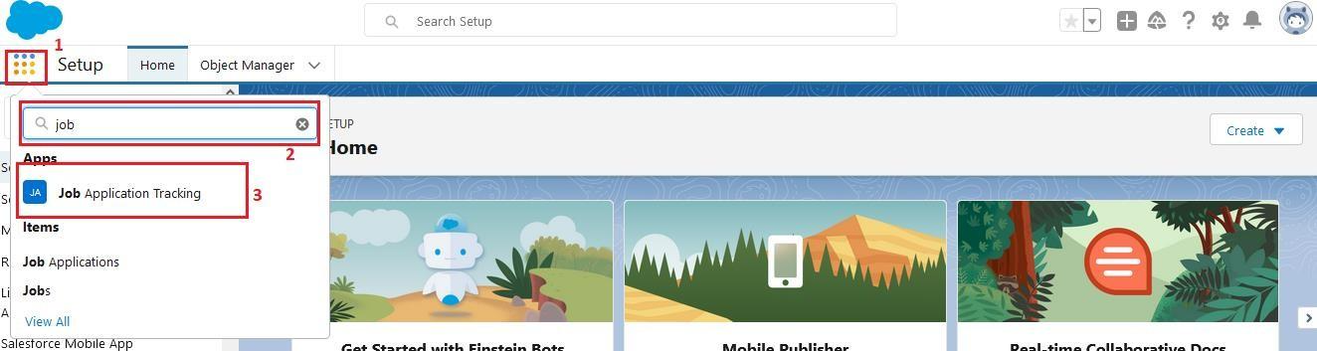

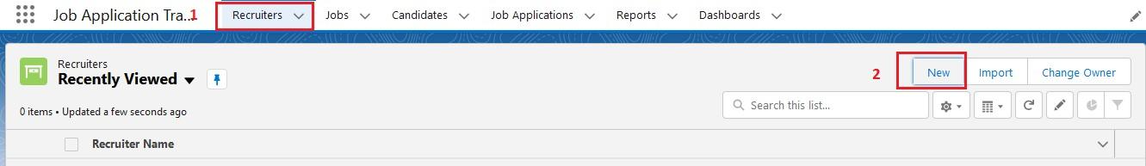

**[](https://apsche.smartinternz.com/Student/guided_project_info/6481)**[Toggle navigation](https://apsche.smartinternz.com/Student/guided_project_info/6481)

* [**0**](https://apsche.smartinternz.com/Student/guided_project_info/6481)
* [**Dashboard**](https://apsche.smartinternz.com/Student/dashboard)
* [**Internship**](https://apsche.smartinternz.com/Student/externships)
* [**Support**](https://apsche.smartinternz.com/Student/support)
* [**Training Calendar**](https://apsche.smartinternz.com/Student/training_calendar)
* [**Guided Project**](https://apsche.smartinternz.com/Student/guided_project_info/6481#menu1)
* [**Project Workspace**](https://apsche.smartinternz.com/Student/guided_project_workspace/6481)



* Job Application Tracking System - (Developer)
  + Salesforce
    - Creating A Salesforce Developer Org
  + Object
    - Create A Custom Object For Recruiter
    - Creation Of Jobs Object
    - Creation Of Candidate Object
    - Creation Of Job Application Object
  + Tab
    - Creation Of Recruiter Tab
    - Creation Of Job Tab
    - Creation Of Candidate Tab
    - Creation Of Job Application Tab
  + Lightning App
    - Create The Job Application Tracking App
  + Fields And Relationship
    - Creation Of Fields For The Recruiter Objects
    - Creation Of Fields For The Job Objects
    - Creation Of Master-Detail Relationship For Job Object
    - Creation Of Fields For The Candidate Object
    - Create Picklist Fields On Candidate Object
    - Create Field Dependency (On Candidate Object)
    - Creation Lookup Relationship For The Job Application Objects
  + Profile
    - Create A Custom Profile
    - Create A Custom Profile-2
  + Role
    - Creation Of Role
  + User
    - To Create A User
    - Create Another User
  + Sharing Rules
    - Create A Sharing Rule
    - Another Sharing Rule
  + User Adoption
    - Create A Record(Recruiter)
    - View A Record(Recruiter)
    - Delete A Record(Recruiter)
  + Reports
  + Dashboard
  + View Report And Dashboard
  + Flows

**View A Record(Recruiter)**

* Click on App Launcher on left side of screen.
* Search Job Application Tracking & click on it.
* Click on Recruiter Tab.
* Click on any record name. you can see the details of the Event.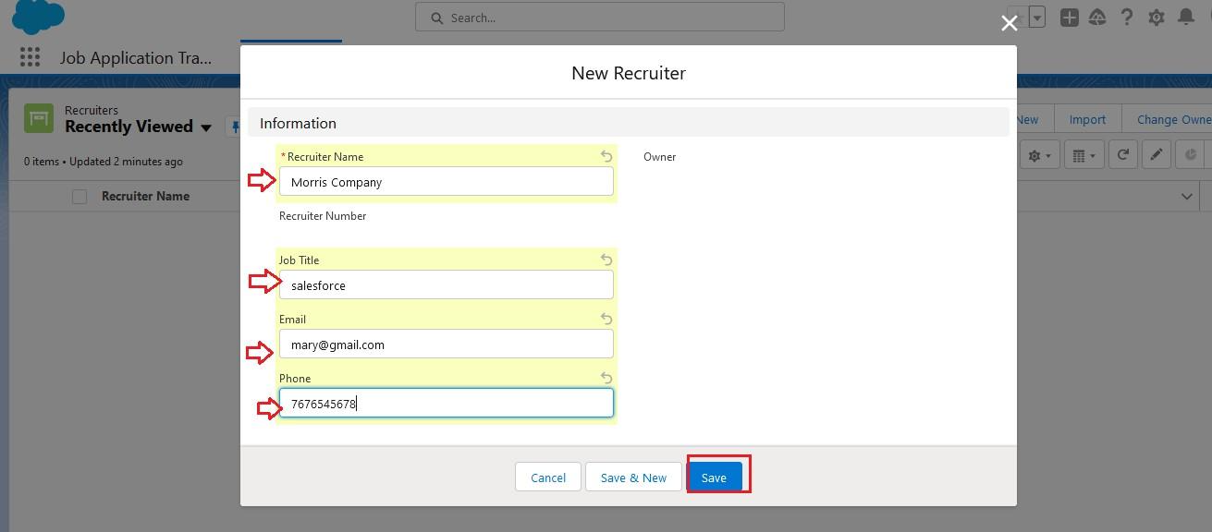

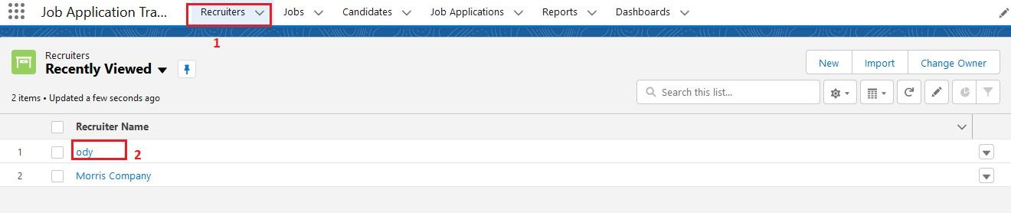

**[](https://apsche.smartinternz.com/Student/guided_project_info/6481)**[Toggle navigation](https://apsche.smartinternz.com/Student/guided_project_info/6481)

* [**0**](https://apsche.smartinternz.com/Student/guided_project_info/6481)
* [**Dashboard**](https://apsche.smartinternz.com/Student/dashboard)
* [**Internship**](https://apsche.smartinternz.com/Student/externships)
* [**Support**](https://apsche.smartinternz.com/Student/support)
* [**Training Calendar**](https://apsche.smartinternz.com/Student/training_calendar)
* [**Guided Project**](https://apsche.smartinternz.com/Student/guided_project_info/6481#menu1)
* [**Project Workspace**](https://apsche.smartinternz.com/Student/guided_project_workspace/6481)



* Job Application Tracking System - (Developer)
  + Salesforce
    - Creating A Salesforce Developer Org
  + Object
    - Create A Custom Object For Recruiter
    - Creation Of Jobs Object
    - Creation Of Candidate Object
    - Creation Of Job Application Object
  + Tab
    - Creation Of Recruiter Tab
    - Creation Of Job Tab
    - Creation Of Candidate Tab
    - Creation Of Job Application Tab
  + Lightning App
    - Create The Job Application Tracking App
  + Fields And Relationship
    - Creation Of Fields For The Recruiter Objects
    - Creation Of Fields For The Job Objects
    - Creation Of Master-Detail Relationship For Job Object
    - Creation Of Fields For The Candidate Object
    - Create Picklist Fields On Candidate Object
    - Create Field Dependency (On Candidate Object)
    - Creation Lookup Relationship For The Job Application Objects
  + Profile
    - Create A Custom Profile
    - Create A Custom Profile-2
  + Role
    - Creation Of Role
  + User
    - To Create A User
    - Create Another User
  + Sharing Rules
    - Create A Sharing Rule
    - Another Sharing Rule
  + User Adoption
    - Create A Record(Recruiter)
    - View A Record(Recruiter)
    - Delete A Record(Recruiter)
  + Reports
  + Dashboard
  + View Report And Dashboard
  + Flows

**Delete A Record(Recruiter)**

* Click on App Launcher on left side of screen.
* Search Job Application Tracking & click on it.
* Click on Recruiter Tab.
* Click on Arrow at right hand side on that Particular record.
* Click delete and delete again.

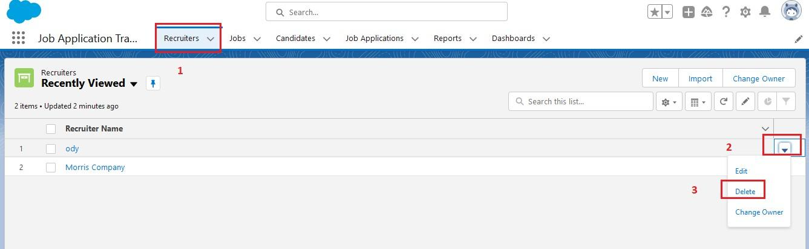

**[](https://apsche.smartinternz.com/Student/guided_project_info/6481)**[Toggle navigation](https://apsche.smartinternz.com/Student/guided_project_info/6481)

* [**0**](https://apsche.smartinternz.com/Student/guided_project_info/6481)
* [**Dashboard**](https://apsche.smartinternz.com/Student/dashboard)
* [**Internship**](https://apsche.smartinternz.com/Student/externships)
* [**Support**](https://apsche.smartinternz.com/Student/support)
* [**Training Calendar**](https://apsche.smartinternz.com/Student/training_calendar)
* [**Guided Project**](https://apsche.smartinternz.com/Student/guided_project_info/6481#menu1)
* [**Project Workspace**](https://apsche.smartinternz.com/Student/guided_project_workspace/6481)



* Job Application Tracking System - (Developer)
  + Salesforce
    - Creating A Salesforce Developer Org
  + Object
    - Create A Custom Object For Recruiter
    - Creation Of Jobs Object
    - Creation Of Candidate Object
    - Creation Of Job Application Object
  + Tab
    - Creation Of Recruiter Tab
    - Creation Of Job Tab
    - Creation Of Candidate Tab
    - Creation Of Job Application Tab
  + Lightning App
    - Create The Job Application Tracking App
  + Fields And Relationship
    - Creation Of Fields For The Recruiter Objects
    - Creation Of Fields For The Job Objects
    - Creation Of Master-Detail Relationship For Job Object
    - Creation Of Fields For The Candidate Object
    - Create Picklist Fields On Candidate Object
    - Create Field Dependency (On Candidate Object)
    - Creation Lookup Relationship For The Job Application Objects
  + Profile
    - Create A Custom Profile
    - Create A Custom Profile-2
  + Role
    - Creation Of Role
  + User
    - To Create A User
    - Create Another User
  + Sharing Rules
    - Create A Sharing Rule
    - Another Sharing Rule
  + User Adoption
    - Create A Record(Recruiter)
    - View A Record(Recruiter)
    - Delete A Record(Recruiter)
  + Reports
    - Create A Report
    - Create Another Report
  + Dashboard
  + View Report And Dashboard
  + Flows

**Reports**

What are Reports?  
A report is a list of records that meet the criteria you define. It's displayed in rows and columns, and can be filtered, grouped, or displayed in a graphical chart. Every report is stored in a folder. Folders can be public, hidden, or shared, and can be set to read-only or read/write.

**[](https://apsche.smartinternz.com/Student/guided_project_info/6481)**[Toggle navigation](https://apsche.smartinternz.com/Student/guided_project_info/6481)

* [**0**](https://apsche.smartinternz.com/Student/guided_project_info/6481)
* [**Dashboard**](https://apsche.smartinternz.com/Student/dashboard)
* [**Internship**](https://apsche.smartinternz.com/Student/externships)
* [**Support**](https://apsche.smartinternz.com/Student/support)
* [**Training Calendar**](https://apsche.smartinternz.com/Student/training_calendar)
* [**Guided Project**](https://apsche.smartinternz.com/Student/guided_project_info/6481#menu1)
* [**Project Workspace**](https://apsche.smartinternz.com/Student/guided_project_workspace/6481)



* Job Application Tracking System - (Developer)
  + Salesforce
    - Creating A Salesforce Developer Org
  + Object
    - Create A Custom Object For Recruiter
    - Creation Of Jobs Object
    - Creation Of Candidate Object
    - Creation Of Job Application Object
  + Tab
    - Creation Of Recruiter Tab
    - Creation Of Job Tab
    - Creation Of Candidate Tab
    - Creation Of Job Application Tab
  + Lightning App
    - Create The Job Application Tracking App
  + Fields And Relationship
    - Creation Of Fields For The Recruiter Objects
    - Creation Of Fields For The Job Objects
    - Creation Of Master-Detail Relationship For Job Object
    - Creation Of Fields For The Candidate Object
    - Create Picklist Fields On Candidate Object
    - Create Field Dependency (On Candidate Object)
    - Creation Lookup Relationship For The Job Application Objects
  + Profile
    - Create A Custom Profile
    - Create A Custom Profile-2
  + Role
    - Creation Of Role
  + User
    - To Create A User
    - Create Another User
  + Sharing Rules
    - Create A Sharing Rule
    - Another Sharing Rule
  + User Adoption
    - Create A Record(Recruiter)
    - View A Record(Recruiter)
    - Delete A Record(Recruiter)
  + Reports
    - Create A Report
    - Create Another Report
  + Dashboard
  + View Report And Dashboard
  + Flows

**Create A Report**

Create a report that displays rating of the account and which has type and account name.

1.Click on app launcher search for reports.  
2.Click on the new report and select the category has job application with candidate name.

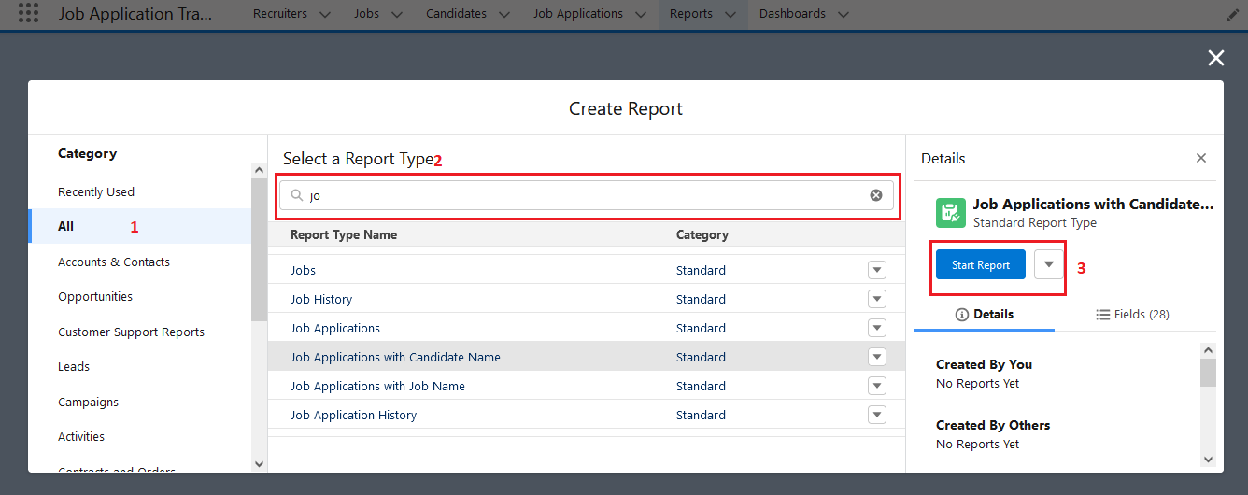

3.In the details section select the option start report.  
4.show me my job application and job application created date(All time)  
5.In the outline pane, group rows select job application created date.

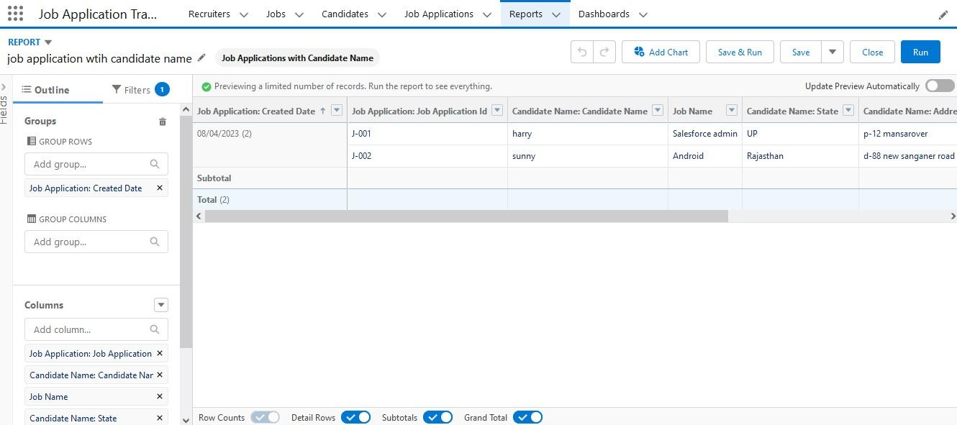

6.Save the report by giving label name(Job application wtih candidate name) and save the folder as a public folder and save the report.

**[](https://apsche.smartinternz.com/Student/guided_project_info/6481)**[Toggle navigation](https://apsche.smartinternz.com/Student/guided_project_info/6481)

* [**0**](https://apsche.smartinternz.com/Student/guided_project_info/6481)
* [**Dashboard**](https://apsche.smartinternz.com/Student/dashboard)
* [**Internship**](https://apsche.smartinternz.com/Student/externships)
* [**Support**](https://apsche.smartinternz.com/Student/support)
* [**Training Calendar**](https://apsche.smartinternz.com/Student/training_calendar)
* [**Guided Project**](https://apsche.smartinternz.com/Student/guided_project_info/6481#menu1)
* [**Project Workspace**](https://apsche.smartinternz.com/Student/guided_project_workspace/6481)



* Job Application Tracking System - (Developer)
  + Salesforce
    - Creating A Salesforce Developer Org
  + Object
    - Create A Custom Object For Recruiter
    - Creation Of Jobs Object
    - Creation Of Candidate Object
    - Creation Of Job Application Object
  + Tab
    - Creation Of Recruiter Tab
    - Creation Of Job Tab
    - Creation Of Candidate Tab
    - Creation Of Job Application Tab
  + Lightning App
    - Create The Job Application Tracking App
  + Fields And Relationship
    - Creation Of Fields For The Recruiter Objects
    - Creation Of Fields For The Job Objects
    - Creation Of Master-Detail Relationship For Job Object
    - Creation Of Fields For The Candidate Object
    - Create Picklist Fields On Candidate Object
    - Create Field Dependency (On Candidate Object)
    - Creation Lookup Relationship For The Job Application Objects
  + Profile
    - Create A Custom Profile
    - Create A Custom Profile-2
  + Role
    - Creation Of Role
  + User
    - To Create A User
    - Create Another User
  + Sharing Rules
    - Create A Sharing Rule
    - Another Sharing Rule
  + User Adoption
    - Create A Record(Recruiter)
    - View A Record(Recruiter)
    - Delete A Record(Recruiter)
  + Reports
    - Create A Report
    - Create Another Report
  + Dashboard
  + View Report And Dashboard
  + Flows

**Create Another Report**

Create a Report using the Objects Jobs, Candidate and Job Application. Follow the steps from above Activity.

**[](https://apsche.smartinternz.com/Student/guided_project_info/6481)**[Toggle navigation](https://apsche.smartinternz.com/Student/guided_project_info/6481)

* [**0**](https://apsche.smartinternz.com/Student/guided_project_info/6481)
* [**Dashboard**](https://apsche.smartinternz.com/Student/dashboard)
* [**Internship**](https://apsche.smartinternz.com/Student/externships)
* [**Support**](https://apsche.smartinternz.com/Student/support)
* [**Training Calendar**](https://apsche.smartinternz.com/Student/training_calendar)
* [**Guided Project**](https://apsche.smartinternz.com/Student/guided_project_info/6481#menu1)
* [**Project Workspace**](https://apsche.smartinternz.com/Student/guided_project_workspace/6481)



* Job Application Tracking System - (Developer)
  + Salesforce
    - Creating A Salesforce Developer Org
  + Object
    - Create A Custom Object For Recruiter
    - Creation Of Jobs Object
    - Creation Of Candidate Object
    - Creation Of Job Application Object
  + Tab
    - Creation Of Recruiter Tab
    - Creation Of Job Tab
    - Creation Of Candidate Tab
    - Creation Of Job Application Tab
  + Lightning App
    - Create The Job Application Tracking App
  + Fields And Relationship
    - Creation Of Fields For The Recruiter Objects
    - Creation Of Fields For The Job Objects
    - Creation Of Master-Detail Relationship For Job Object
    - Creation Of Fields For The Candidate Object
    - Create Picklist Fields On Candidate Object
    - Create Field Dependency (On Candidate Object)
    - Creation Lookup Relationship For The Job Application Objects
  + Profile
    - Create A Custom Profile
    - Create A Custom Profile-2
  + Role
    - Creation Of Role
  + User
    - To Create A User
    - Create Another User
  + Sharing Rules
    - Create A Sharing Rule
    - Another Sharing Rule
  + User Adoption
    - Create A Record(Recruiter)
    - View A Record(Recruiter)
    - Delete A Record(Recruiter)
  + Reports
    - Create A Report
    - Create Another Report
  + Dashboard
    - Create A Dashboard
  + View Report And Dashboard
  + Flows

**Dashboard**

Dashboards provide more insights than reports as they combine the data from many reports and show a summarized result. Looking at many reports at a time gives the flexibility of combining the results from them quickly. Also summaries in dashboards help us decide on action plans quicker. The dashboards can contain charts, graphs and Tabular data.

**[](https://apsche.smartinternz.com/Student/guided_project_info/6481)**[Toggle navigation](https://apsche.smartinternz.com/Student/guided_project_info/6481)

* [**0**](https://apsche.smartinternz.com/Student/guided_project_info/6481)
* [**Dashboard**](https://apsche.smartinternz.com/Student/dashboard)
* [**Internship**](https://apsche.smartinternz.com/Student/externships)
* [**Support**](https://apsche.smartinternz.com/Student/support)
* [**Training Calendar**](https://apsche.smartinternz.com/Student/training_calendar)
* [**Guided Project**](https://apsche.smartinternz.com/Student/guided_project_info/6481#menu1)
* [**Project Workspace**](https://apsche.smartinternz.com/Student/guided_project_workspace/6481)



* Job Application Tracking System - (Developer)
  + Salesforce
    - Creating A Salesforce Developer Org
  + Object
    - Create A Custom Object For Recruiter
    - Creation Of Jobs Object
    - Creation Of Candidate Object
    - Creation Of Job Application Object
  + Tab
    - Creation Of Recruiter Tab
    - Creation Of Job Tab
    - Creation Of Candidate Tab
    - Creation Of Job Application Tab
  + Lightning App
    - Create The Job Application Tracking App
  + Fields And Relationship
    - Creation Of Fields For The Recruiter Objects
    - Creation Of Fields For The Job Objects
    - Creation Of Master-Detail Relationship For Job Object
    - Creation Of Fields For The Candidate Object
    - Create Picklist Fields On Candidate Object
    - Create Field Dependency (On Candidate Object)
    - Creation Lookup Relationship For The Job Application Objects
  + Profile
    - Create A Custom Profile
    - Create A Custom Profile-2
  + Role
    - Creation Of Role
  + User
    - To Create A User
    - Create Another User
  + Sharing Rules
    - Create A Sharing Rule
    - Another Sharing Rule
  + User Adoption
    - Create A Record(Recruiter)
    - View A Record(Recruiter)
    - Delete A Record(Recruiter)
  + Reports
    - Create A Report
    - Create Another Report
  + Dashboard
    - Create A Dashboard
  + View Report And Dashboard

 Flows**[](https://apsche.smartinternz.com/Student/guided_project_info/6481)**[Toggle navigation](https://apsche.smartinternz.com/Student/guided_project_info/6481)

* [**0**](https://apsche.smartinternz.com/Student/guided_project_info/6481)
* [**Dashboard**](https://apsche.smartinternz.com/Student/dashboard)
* [**Internship**](https://apsche.smartinternz.com/Student/externships)
* [**Support**](https://apsche.smartinternz.com/Student/support)
* [**Training Calendar**](https://apsche.smartinternz.com/Student/training_calendar)
* [**Guided Project**](https://apsche.smartinternz.com/Student/guided_project_info/6481#menu1)
* [**Project Workspace**](https://apsche.smartinternz.com/Student/guided_project_workspace/6481)



* Job Application Tracking System - (Developer)
  + Salesforce
    - Creating A Salesforce Developer Org
  + Object
    - Create A Custom Object For Recruiter
    - Creation Of Jobs Object
    - Creation Of Candidate Object
    - Creation Of Job Application Object
  + Tab
    - Creation Of Recruiter Tab
    - Creation Of Job Tab
    - Creation Of Candidate Tab
    - Creation Of Job Application Tab
  + Lightning App
    - Create The Job Application Tracking App
  + Fields And Relationship
    - Creation Of Fields For The Recruiter Objects
    - Creation Of Fields For The Job Objects
    - Creation Of Master-Detail Relationship For Job Object
    - Creation Of Fields For The Candidate Object
    - Create Picklist Fields On Candidate Object
    - Create Field Dependency (On Candidate Object)
    - Creation Lookup Relationship For The Job Application Objects
  + Profile
    - Create A Custom Profile
    - Create A Custom Profile-2
  + Role
    - Creation Of Role
  + User
    - To Create A User
    - Create Another User
  + Sharing Rules
    - Create A Sharing Rule
    - Another Sharing Rule
  + User Adoption
    - Create A Record(Recruiter)
    - View A Record(Recruiter)
    - Delete A Record(Recruiter)
  + Reports
    - Create A Report
    - Create Another Report
  + Dashboard
    - Create A Dashboard
  + View Report And Dashboard
  + Flows

**Create A Dashboard**

1. Click the Dashboards tab.
2. Click New Dashboard.
3. Name the dashboard Job application wtih candidate name and click Create.
4. Click +Component.
5. Select the Job application wtih candidate name and click Select.
6. Select the Gauge chart and click Add.
7. Click Save and then Done.

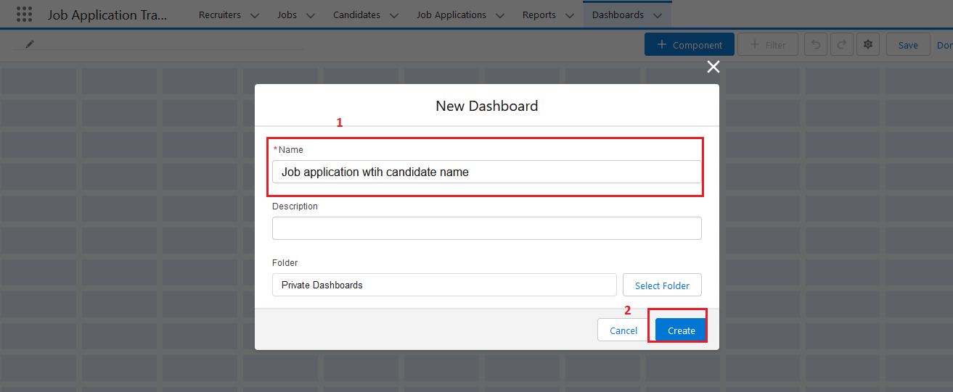  
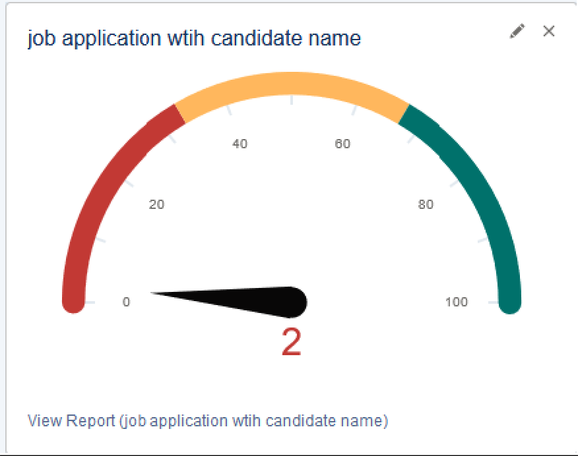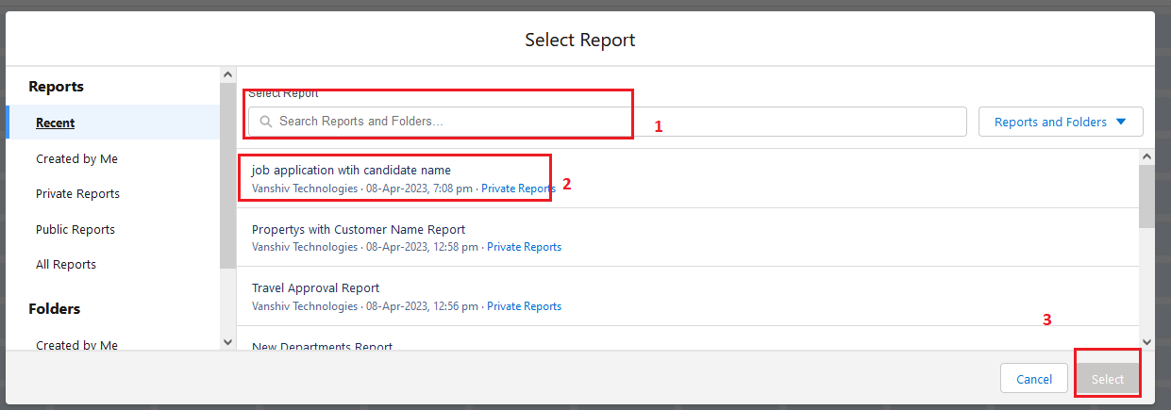

**[](https://apsche.smartinternz.com/Student/guided_project_info/6481)**[Toggle navigation](https://apsche.smartinternz.com/Student/guided_project_info/6481)

* [**0**](https://apsche.smartinternz.com/Student/guided_project_info/6481)
* [**Dashboard**](https://apsche.smartinternz.com/Student/dashboard)
* [**Internship**](https://apsche.smartinternz.com/Student/externships)
* [**Support**](https://apsche.smartinternz.com/Student/support)
* [**Training Calendar**](https://apsche.smartinternz.com/Student/training_calendar)
* [**Guided Project**](https://apsche.smartinternz.com/Student/guided_project_info/6481#menu1)
* [**Project Workspace**](https://apsche.smartinternz.com/Student/guided_project_workspace/6481)



* Job Application Tracking System - (Developer)
  + Salesforce
    - Creating A Salesforce Developer Org
  + Object
    - Create A Custom Object For Recruiter
    - Creation Of Jobs Object
    - Creation Of Candidate Object
    - Creation Of Job Application Object
  + Tab
    - Creation Of Recruiter Tab
    - Creation Of Job Tab
    - Creation Of Candidate Tab
    - Creation Of Job Application Tab
  + Lightning App
    - Create The Job Application Tracking App
  + Fields And Relationship
    - Creation Of Fields For The Recruiter Objects
    - Creation Of Fields For The Job Objects
    - Creation Of Master-Detail Relationship For Job Object
    - Creation Of Fields For The Candidate Object
    - Create Picklist Fields On Candidate Object
    - Create Field Dependency (On Candidate Object)
    - Creation Lookup Relationship For The Job Application Objects
  + Profile
    - Create A Custom Profile
    - Create A Custom Profile-2
  + Role
    - Creation Of Role
  + User
    - To Create A User
    - Create Another User
  + Sharing Rules
    - Create A Sharing Rule
    - Another Sharing Rule
  + User Adoption
    - Create A Record(Recruiter)
    - View A Record(Recruiter)
    - Delete A Record(Recruiter)
  + Reports
    - Create A Report
    - Create Another Report
  + Dashboard
    - Create A Dashboard
  + View Report And Dashboard
    - Report
    - Dashboard
  + Flows

**View Report And Dashboard**

**[](https://apsche.smartinternz.com/Student/guided_project_info/6481)**[Toggle navigation](https://apsche.smartinternz.com/Student/guided_project_info/6481)

* [**0**](https://apsche.smartinternz.com/Student/guided_project_info/6481)
* [**Dashboard**](https://apsche.smartinternz.com/Student/dashboard)
* [**Internship**](https://apsche.smartinternz.com/Student/externships)
* [**Support**](https://apsche.smartinternz.com/Student/support)
* [**Training Calendar**](https://apsche.smartinternz.com/Student/training_calendar)
* [**Guided Project**](https://apsche.smartinternz.com/Student/guided_project_info/6481#menu1)
* [**Project Workspace**](https://apsche.smartinternz.com/Student/guided_project_workspace/6481)



* Job Application Tracking System - (Developer)
  + Salesforce
    - Creating A Salesforce Developer Org
  + Object
    - Create A Custom Object For Recruiter
    - Creation Of Jobs Object
    - Creation Of Candidate Object
    - Creation Of Job Application Object
  + Tab
    - Creation Of Recruiter Tab
    - Creation Of Job Tab
    - Creation Of Candidate Tab
    - Creation Of Job Application Tab
  + Lightning App
    - Create The Job Application Tracking App
  + Fields And Relationship
    - Creation Of Fields For The Recruiter Objects
    - Creation Of Fields For The Job Objects
    - Creation Of Master-Detail Relationship For Job Object
    - Creation Of Fields For The Candidate Object
    - Create Picklist Fields On Candidate Object
    - Create Field Dependency (On Candidate Object)
    - Creation Lookup Relationship For The Job Application Objects
  + Profile
    - Create A Custom Profile
    - Create A Custom Profile-2
  + Role
    - Creation Of Role
  + User
    - To Create A User
    - Create Another User
  + Sharing Rules
    - Create A Sharing Rule
    - Another Sharing Rule
  + User Adoption
    - Create A Record(Recruiter)
    - View A Record(Recruiter)
    - Delete A Record(Recruiter)
  + Reports
    - Create A Report
    - Create Another Report
  + Dashboard
    - Create A Dashboard
  + View Report And Dashboard
    - Report
    - Dashboard
  + Flows

**Report**

* Click on App Launcher on left side of screen.
* Search Job Application & click on it.
* Click on Reports Tab.
* Click on [job application wtih candidate name](https://vanshivtechnologyprivatelim-dev-ed.develop.lightning.force.com/lightning/r/sObject/00O2w00000EeBxDEAV/view?queryScope=userFolders) & see records

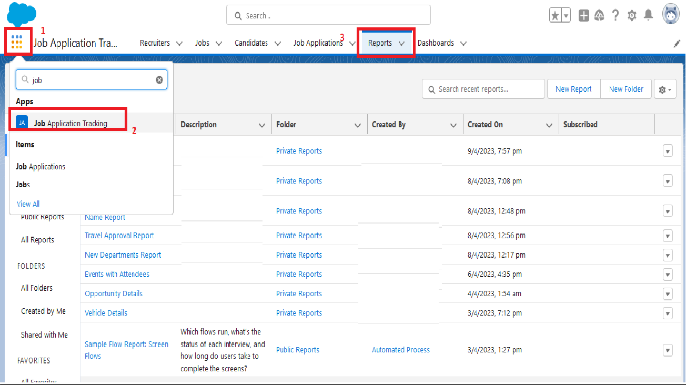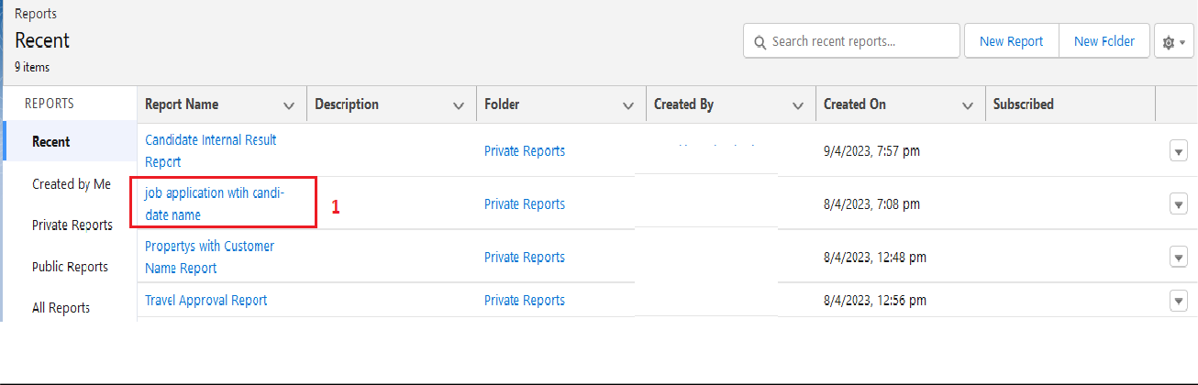



**[](https://apsche.smartinternz.com/Student/guided_project_info/6481)**[Toggle navigation](https://apsche.smartinternz.com/Student/guided_project_info/6481)

* [**0**](https://apsche.smartinternz.com/Student/guided_project_info/6481)
* [**Dashboard**](https://apsche.smartinternz.com/Student/dashboard)
* [**Internship**](https://apsche.smartinternz.com/Student/externships)
* [**Support**](https://apsche.smartinternz.com/Student/support)
* [**Training Calendar**](https://apsche.smartinternz.com/Student/training_calendar)
* [**Guided Project**](https://apsche.smartinternz.com/Student/guided_project_info/6481#menu1)
* [**Project Workspace**](https://apsche.smartinternz.com/Student/guided_project_workspace/6481)



* Job Application Tracking System - (Developer)
  + Salesforce
    - Creating A Salesforce Developer Org
  + Object
    - Create A Custom Object For Recruiter
    - Creation Of Jobs Object
    - Creation Of Candidate Object
    - Creation Of Job Application Object
  + Tab
    - Creation Of Recruiter Tab
    - Creation Of Job Tab
    - Creation Of Candidate Tab
    - Creation Of Job Application Tab
  + Lightning App
    - Create The Job Application Tracking App
  + Fields And Relationship
    - Creation Of Fields For The Recruiter Objects
    - Creation Of Fields For The Job Objects
    - Creation Of Master-Detail Relationship For Job Object
    - Creation Of Fields For The Candidate Object
    - Create Picklist Fields On Candidate Object
    - Create Field Dependency (On Candidate Object)
    - Creation Lookup Relationship For The Job Application Objects
  + Profile
    - Create A Custom Profile
    - Create A Custom Profile-2
  + Role
    - Creation Of Role
  + User
    - To Create A User
    - Create Another User
  + Sharing Rules
    - Create A Sharing Rule
    - Another Sharing Rule
  + User Adoption
    - Create A Record(Recruiter)
    - View A Record(Recruiter)
    - Delete A Record(Recruiter)
  + Reports
    - Create A Report
    - Create Another Report
  + Dashboard
    - Create A Dashboard
  + View Report And Dashboard
    - Report
    - Dashboard
  + Flows

**Dashboard**

* Click on App Launcher on left side of screen.
* Search job application & click on it.
* Click on Dashboard Tab.
* Click on [job application wtih candidate name](https://vanshivtechnologyprivatelim-dev-ed.develop.lightning.force.com/lightning/r/sObject/00O2w00000EeBxDEAV/view?queryScope=userFolders) & see records

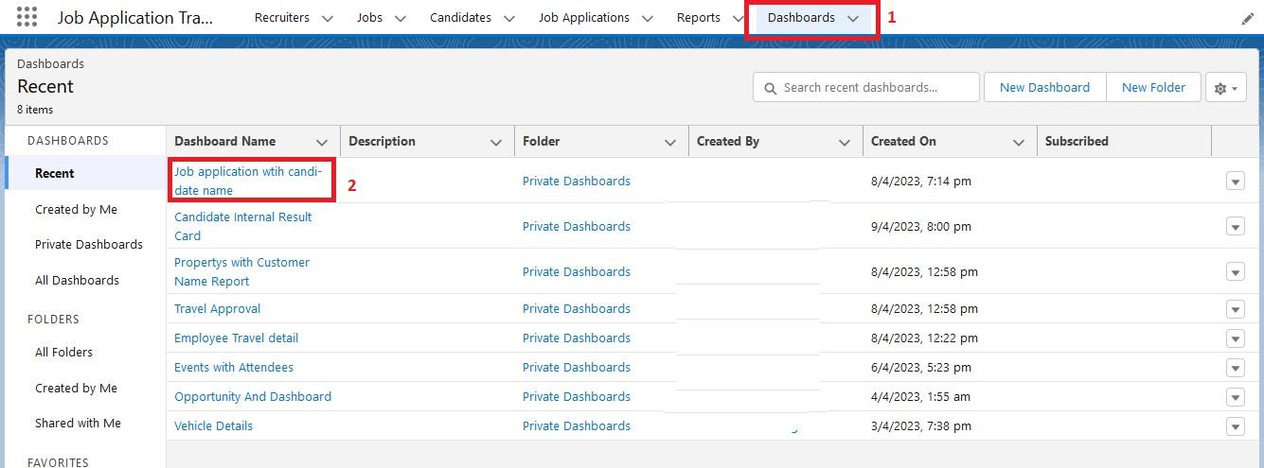

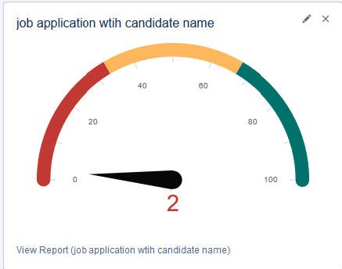

**[](https://apsche.smartinternz.com/Student/guided_project_info/6481)**[Toggle navigation](https://apsche.smartinternz.com/Student/guided_project_info/6481)

* [**0**](https://apsche.smartinternz.com/Student/guided_project_info/6481)
* [**Dashboard**](https://apsche.smartinternz.com/Student/dashboard)
* [**Internship**](https://apsche.smartinternz.com/Student/externships)
* [**Support**](https://apsche.smartinternz.com/Student/support)
* [**Training Calendar**](https://apsche.smartinternz.com/Student/training_calendar)
* [**Guided Project**](https://apsche.smartinternz.com/Student/guided_project_info/6481#menu1)
* [**Project Workspace**](https://apsche.smartinternz.com/Student/guided_project_workspace/6481)



* Job Application Tracking System - (Developer)
  + Salesforce
    - Creating A Salesforce Developer Org
  + Object
    - Create A Custom Object For Recruiter
    - Creation Of Jobs Object
    - Creation Of Candidate Object
    - Creation Of Job Application Object
  + Tab
    - Creation Of Recruiter Tab
    - Creation Of Job Tab
    - Creation Of Candidate Tab
    - Creation Of Job Application Tab
  + Lightning App
    - Create The Job Application Tracking App
  + Fields And Relationship
    - Creation Of Fields For The Recruiter Objects
    - Creation Of Fields For The Job Objects
    - Creation Of Master-Detail Relationship For Job Object
    - Creation Of Fields For The Candidate Object
    - Create Picklist Fields On Candidate Object
    - Create Field Dependency (On Candidate Object)
    - Creation Lookup Relationship For The Job Application Objects
  + Profile
    - Create A Custom Profile
    - Create A Custom Profile-2
  + Role
    - Creation Of Role
  + User
    - To Create A User
    - Create Another User
  + Sharing Rules
    - Create A Sharing Rule
    - Another Sharing Rule
  + User Adoption
    - Create A Record(Recruiter)
    - View A Record(Recruiter)
    - Delete A Record(Recruiter)
  + Reports
    - Create A Report
    - Create Another Report
  + Dashboard
    - Create A Dashboard
  + View Report And Dashboard
    - Report
    - Dashboard
  + Flows
    - Create A Record Trigger Flow On Job Object
    - Create Another Flow

**Flows**

 Flows In Salesforce, a flow is a tool that automates complex business processes. Simply put, it collects data and then does something with that data.

Flow Builder is the declarative interface used to build individual flows.

Flow Builder can be used to build code-like logic without using a programming language. Flows fall into five categories:

* Screen Flows
* Schedule-Triggered Flows
* Autolaunched Flows
* Record-Triggered Flows
* Platform Event-Triggered Flows

**[](https://apsche.smartinternz.com/Student/guided_project_info/6481)**[Toggle navigation](https://apsche.smartinternz.com/Student/guided_project_info/6481)

* [**0**](https://apsche.smartinternz.com/Student/guided_project_info/6481)
* [**Dashboard**](https://apsche.smartinternz.com/Student/dashboard)
* [**Internship**](https://apsche.smartinternz.com/Student/externships)
* [**Support**](https://apsche.smartinternz.com/Student/support)
* [**Training Calendar**](https://apsche.smartinternz.com/Student/training_calendar)
* [**Guided Project**](https://apsche.smartinternz.com/Student/guided_project_info/6481#menu1)
* [**Project Workspace**](https://apsche.smartinternz.com/Student/guided_project_workspace/6481)



* Job Application Tracking System - (Developer)
  + Salesforce
    - Creating A Salesforce Developer Org
  + Object
    - Create A Custom Object For Recruiter
    - Creation Of Jobs Object
    - Creation Of Candidate Object
    - Creation Of Job Application Object
  + Tab
    - Creation Of Recruiter Tab
    - Creation Of Job Tab
    - Creation Of Candidate Tab
    - Creation Of Job Application Tab
  + Lightning App
    - Create The Job Application Tracking App
  + Fields And Relationship
    - Creation Of Fields For The Recruiter Objects
    - Creation Of Fields For The Job Objects
    - Creation Of Master-Detail Relationship For Job Object
    - Creation Of Fields For The Candidate Object
    - Create Picklist Fields On Candidate Object
    - Create Field Dependency (On Candidate Object)
    - Creation Lookup Relationship For The Job Application Objects
  + Profile
    - Create A Custom Profile
    - Create A Custom Profile-2
  + Role
    - Creation Of Role
  + User
    - To Create A User
    - Create Another User
  + Sharing Rules
    - Create A Sharing Rule
    - Another Sharing Rule
  + User Adoption
    - Create A Record(Recruiter)
    - View A Record(Recruiter)
    - Delete A Record(Recruiter)
  + Reports
    - Create A Report
    - Create Another Report
  + Dashboard
    - Create A Dashboard
  + View Report And Dashboard
    - Report
    - Dashboard
  + Flows
    - Create A Record Trigger Flow On Job Object
    - Create Another Flow

**Create A Record Trigger Flow On Job Object**

1. Click on Gear icon and select setup
2. In Quick find Box enter flow and select the flows
3. Click on New flow and Select Record triggered Flows.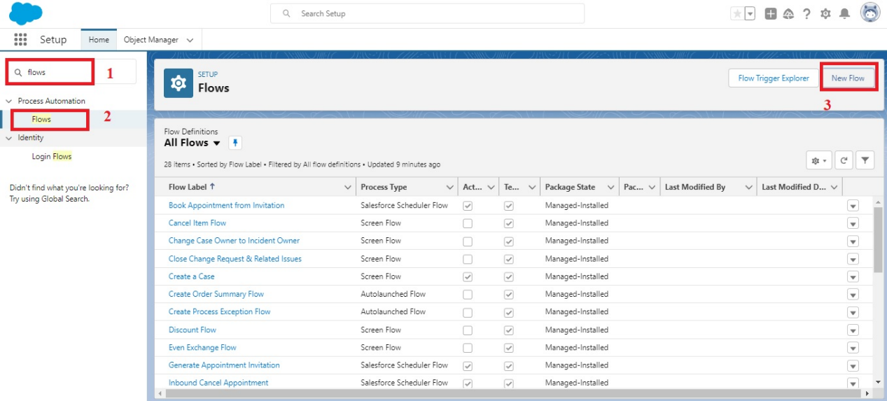

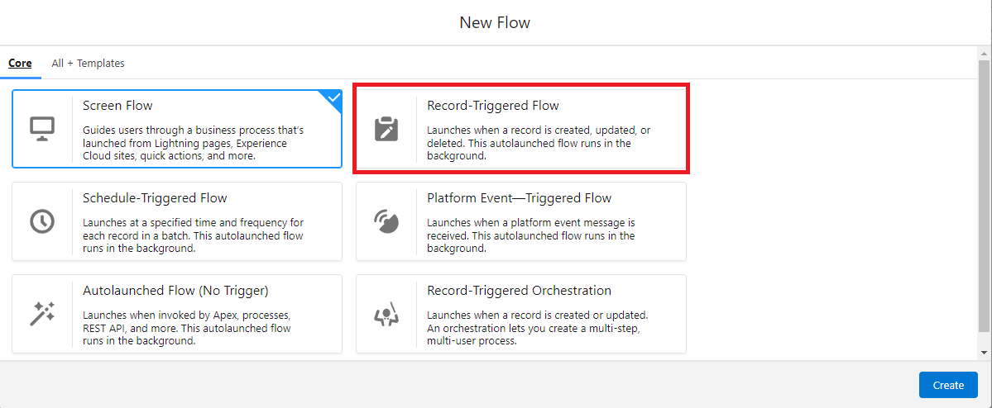

1. In the search bar type job and click done.

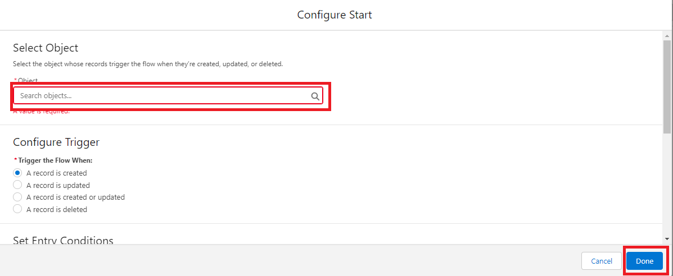

1. Add an element called Get record .
2. Label name as Recruiter  Records.
3. Select the object as Recruiter.
4. After entering the object follow the steps .
5. Conditional requirements should be all conditions are met ( AND ).
6. Select the field as Recruiter_Email__c.
7. Operation should be Is Null .
8. Value should be False. And click done.

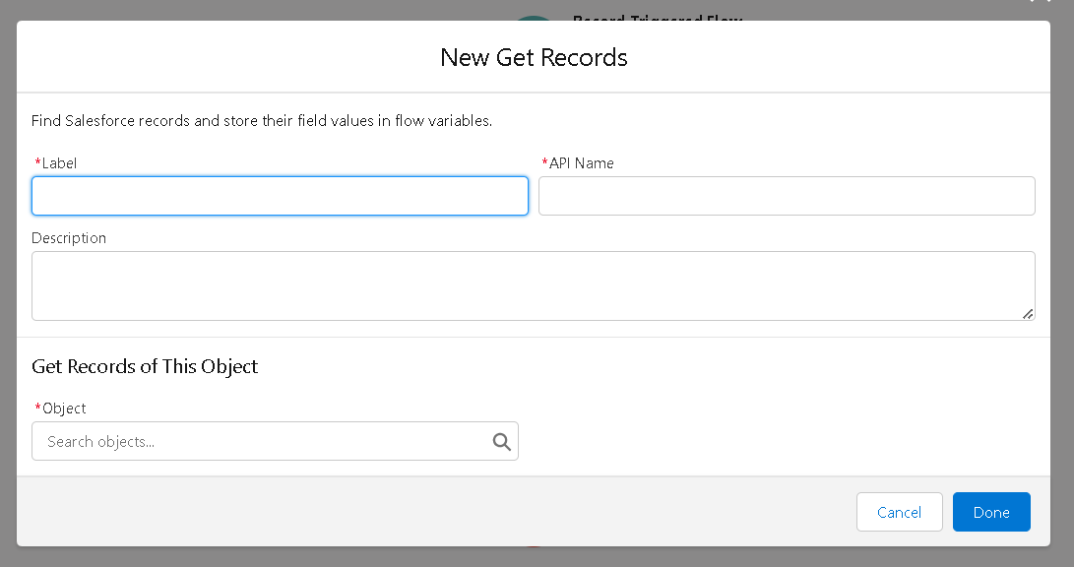

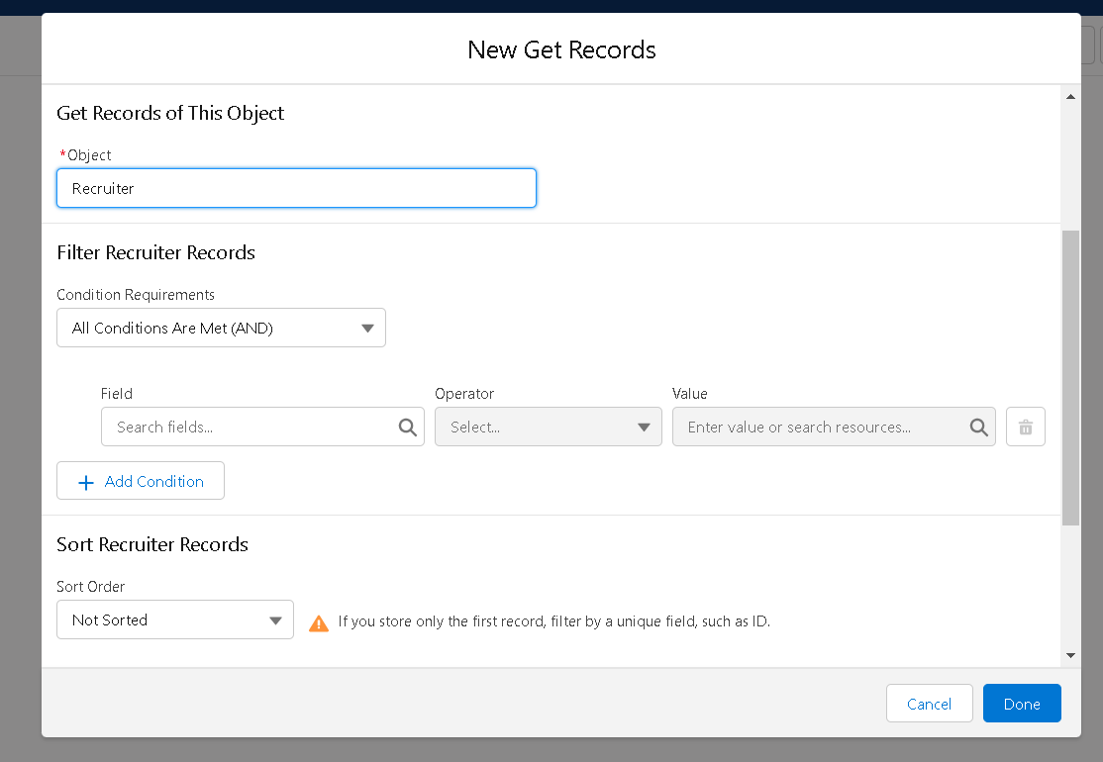

1. Add another element called Action.
2. Click on the Action and start creating new action .

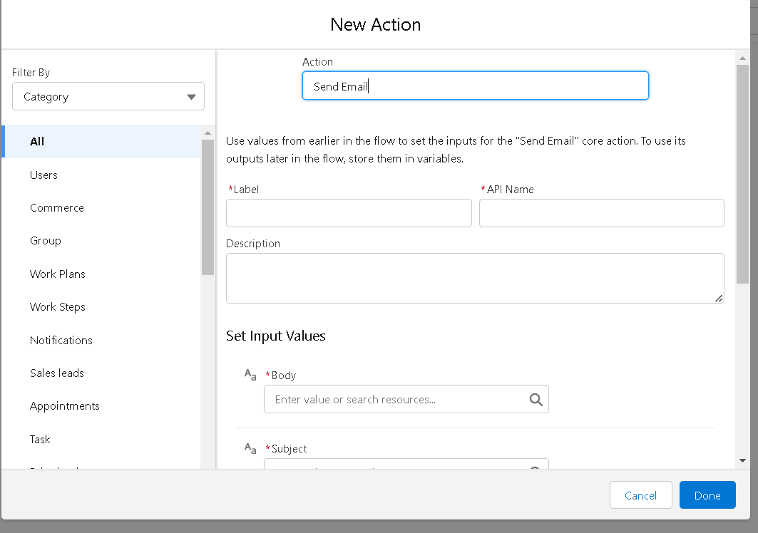

1. Select the action as Send Email .
2. Enter the label name job email, API name is auto populated .
3. Set input values as

              a. Body : {!$Record.Name} with {!$Record.Job_Application_Id__c} is available. Please find the suitable candidates      for the position.

     b. Subject : {!$Record.Name}

1. Recipient Email Addresses (comma-separated) should be included for that turn it on.
   1. Recipient Email Addresses : {!$Record.Recruiter_Name__r.Recruiter_Email__c}

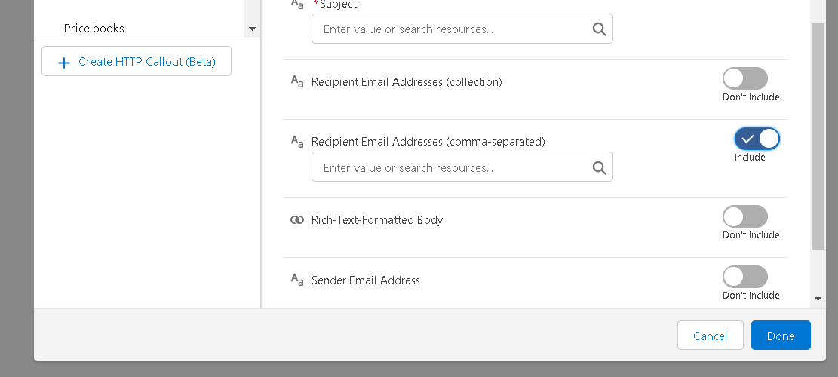

1. Click on done .
2. After the completion of flow,  check whether the flow is running and click save .
3. And Activate the flow .

**[](https://apsche.smartinternz.com/Student/guided_project_info/6481)**[Toggle navigation](https://apsche.smartinternz.com/Student/guided_project_info/6481)

* [**0**](https://apsche.smartinternz.com/Student/guided_project_info/6481)
* [**Dashboard**](https://apsche.smartinternz.com/Student/dashboard)
* [**Internship**](https://apsche.smartinternz.com/Student/externships)
* [**Support**](https://apsche.smartinternz.com/Student/support)
* [**Training Calendar**](https://apsche.smartinternz.com/Student/training_calendar)
* [**Guided Project**](https://apsche.smartinternz.com/Student/guided_project_info/6481#menu1)
* [**Project Workspace**](https://apsche.smartinternz.com/Student/guided_project_workspace/6481)



* Job Application Tracking System - (Developer)
  + Salesforce
    - Creating A Salesforce Developer Org
  + Object
    - Create A Custom Object For Recruiter
    - Creation Of Jobs Object
    - Creation Of Candidate Object
    - Creation Of Job Application Object
  + Tab
    - Creation Of Recruiter Tab
    - Creation Of Job Tab
    - Creation Of Candidate Tab
    - Creation Of Job Application Tab
  + Lightning App
    - Create The Job Application Tracking App
  + Fields And Relationship
    - Creation Of Fields For The Recruiter Objects
    - Creation Of Fields For The Job Objects
    - Creation Of Master-Detail Relationship For Job Object
    - Creation Of Fields For The Candidate Object
    - Create Picklist Fields On Candidate Object
    - Create Field Dependency (On Candidate Object)
    - Creation Lookup Relationship For The Job Application Objects
  + Profile
    - Create A Custom Profile
    - Create A Custom Profile-2
  + Role
    - Creation Of Role
  + User
    - To Create A User
    - Create Another User
  + Sharing Rules
    - Create A Sharing Rule
    - Another Sharing Rule
  + User Adoption
    - Create A Record(Recruiter)
    - View A Record(Recruiter)
    - Delete A Record(Recruiter)
  + Reports
    - Create A Report
    - Create Another Report
  + Dashboard
    - Create A Dashboard
  + View Report And Dashboard
    - Report
    - Dashboard
  + Flows
    - Create A Record Trigger Flow On Job Object
    - Create Another Flow

**Create Another Flow**

1. Click on Gear icon and select setup
2. In Quick find Box enter flow and select the flows
3. Click on New flow and Select Screen Flows.

  
  


1. Add an element called screen .
2. Screen label should be Candidate details.
3. API name is auto populated.
4. Add the components in canvas .
5. Select the text from the components .
6. Label name as Candidate name.
7. API name is auto populated.
8. Select the text area from the components.
9. Label name as Address.
10. API name is auto populated.
11. Select the email from the components.
12. Label name as Email.
13. API name is auto populated.
14. Select the Phone from the components.
15. Label name as Phone.
16. API name is auto populated.
17. Select the picklist from the components.
18. Label name as Education.
19. API name is auto populated.
20. And select the choice as {!pick}.
21. Add a header to the canvas candidate flow for job application .
22. Click on save.

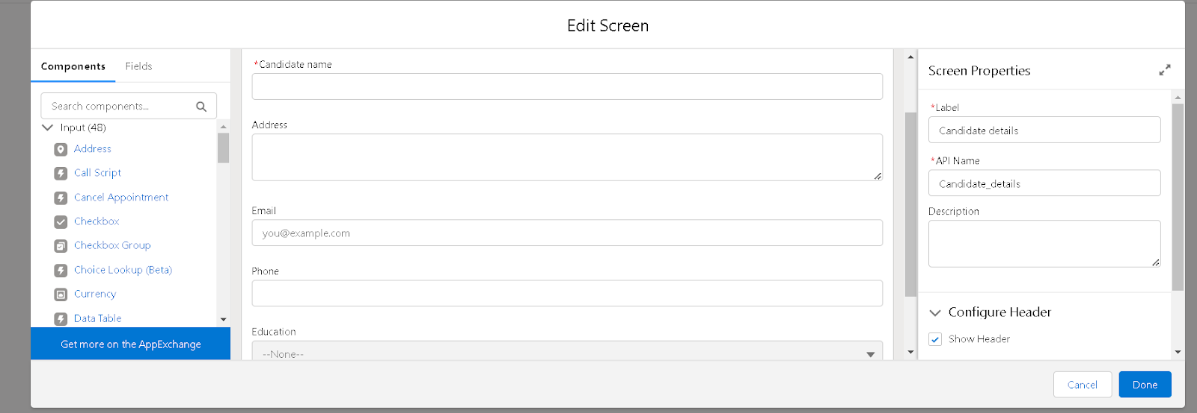

1. Next , add another element called create record .
2. Label name should be Create candidate record.
3. API is auto populated . and change the How to Set the Record Fields  to Use separate resources, and literal values.
4. Select the object  Candidate1.

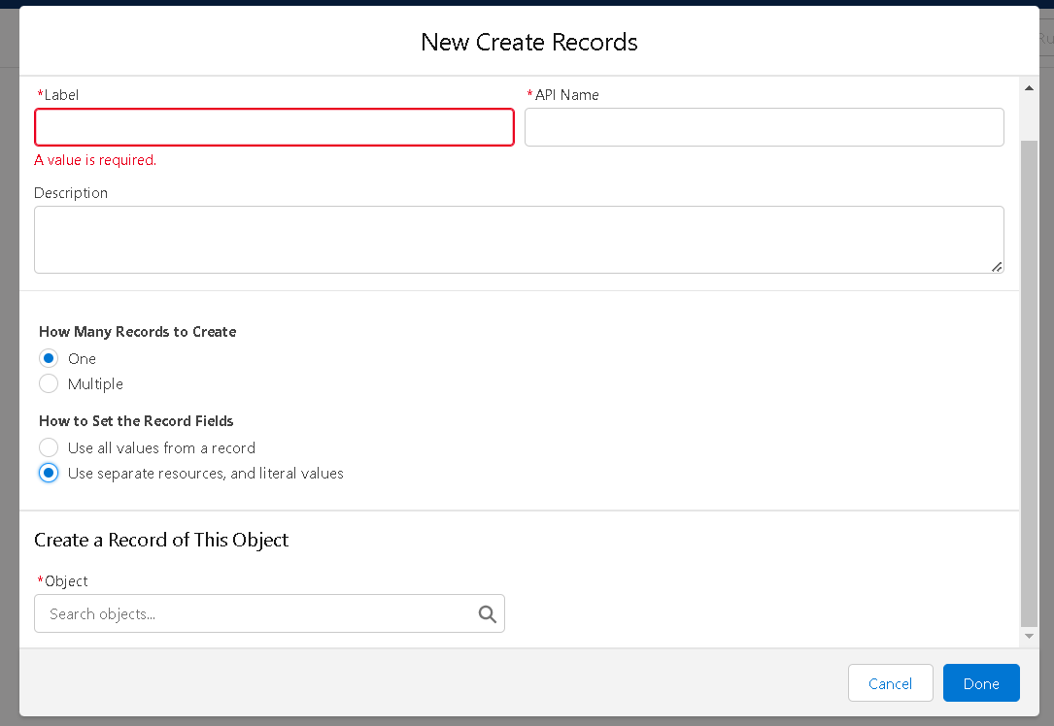

1. Set the values for the candidate1 as
   1. Field is Address__c and value should be {!Address}.
   2. Field is Education__c and value should be {!Education}.
   3. Field is Email__c and value should be {!Email.value}.
   4. Field is Name and value should be {!Candidate_name}.
2. After that click on done.

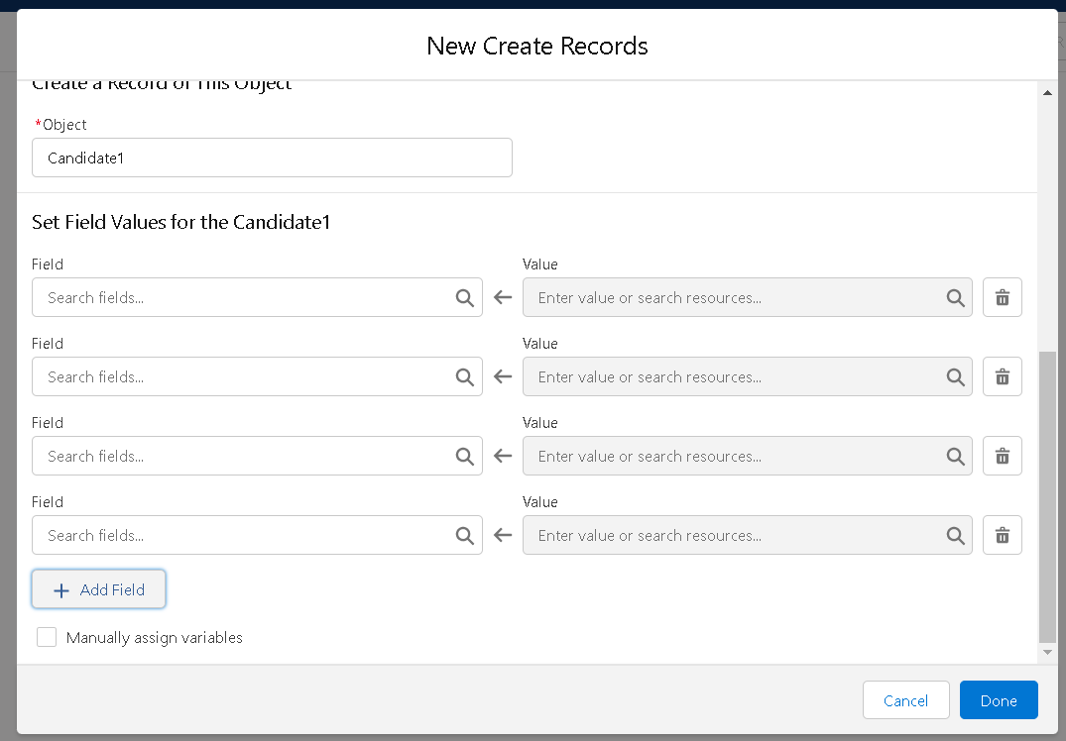

1. Run the flow and check whether the flow is working and click on save.
2. And activate the flow.